In the Wake of Covid-19 Pandemic

Prevention and Management
of
Viral Pandemics/Epidemics:
Islamic Guidelines

Dr. Javed Jamil
Dr. Iffat Masood Javed

Chair in Islamic Studies & Research
Yenepoya (Deemed to be) University
Mangalore

2023

In the Wake of Covid-19 Pandemic

Prevention and Management
of
Viral Pandemics/Epidemics:
Islamic Guidelines

Dr. Javed Jamil
Dr. Iffat Masood Javed

Assisted by
Mashaal Hussain
Sana Khair

Chair in Islamic Studies & Research
Yenepoya (Deemed to be) University
Mangalore

2023

Title:
Prevention and Management of
Viral Pandemics/Epidemics: Islamic Guidelines

Authors:
Dr. Javed Jamil and DR. IFFAT MASOOD JAVED

Edition: First Edition, July, 2023

Copies: 1000

Pages: 162

ISBN (Paperback): 978-93-5913-066-8
Price: INR 350/- (India); US$ 15 (Foreign countries)
Printed at
Thomson Press

Publishers: Authors

Distributors
Mission Publications

Jaypee Kosmos 05/02, Noida, Sector 134, UP

Printed in India

Address for Correspondence:

Dr. Javed Jamil

Chair in Islamic Studies & Research

Yenepoya (Deemed to be) University

Deralakatte, Mangalore, Karnataka - 575018 , India

Ph: 91-8130340339;

Email: doctorforu123@yahoo.com; chairislam@yenepoya.edu.in

Dedicated to
All those Medical Personnel who lost their lives fighting Covid-19

CONTENTS
Preface
  - In Principio: Economics Rules
  - History of Viral Pandemics and Epidemics
  - Strategies adopted to confront Covid-19
  - Long-Term War against Viral Pandemics: Islamic Arsenals
  - Fundamental Prohibitions: Health Protective Measures
  - Statistics Tell the Difference
  - Commerce of the Causes of Problems and the Commerce of Solutions
  - Islamic Philosophy of Holistic Health and Peace Economics
  - Way Forward
  - Last Word
Brief Introduction of the Authors
References

Preface
In the Name of God, Kind-Merciful
Covid-19 pandemic, which has already killed more than six million people in last three years, has been only one of several big killer pandemics and epidemics caused by viruses in last 100-120 years, the other major ones being Swine Flu, HIV/AIDS, HPV, Rabies and Hepatitis B. The factors directly responsible for the spread of these diseases include, among others, pig farming (necessitated by pork eating), sexual malpractices (promiscuity, prostitution, and homosexuality), and consumption of wild animals like pangolins, snakes and bats with Alcohol and Drugs playing the major collaborative role. Obviously, all these and other harmful practices have been prohibited in Islam. In sharp contrast, every one of these substances or practices is a big business today. Moreover, the economic disaster which followed the emergence of COVID-19 Pandemic can also be attributed to dependence on many harmful businesses like various forms of addictions and night clubs (which got temporarily disturbed), huge economic inequality and the failure of the countries of different governments and the international agencies to take early corrective measures (like blocking of international travel from the affected countries).
The current market-driven international system of affairs is neither health-friendly nor conducive of holistic peace. It commercializes not only the human needs but also the human susceptibilities. Islamic guidelines, on the other hand give supremacy to life and healthiness of life; if applied in its totality, they can safeguard against the rise of the many killer diseases as well as in confronting the economic disasters, which normally follow the natural disasters and pandemics.
The experts especially Islamic Economists need to know that Islamic Economics is not just about Islamic Finance and Banking but have much larger ambit. COVID-19 has provided a wonderful opportunity to advance the Islamic philosophies of health and economics through researches and social campaigns at the international level.
Further, it is also to be stressed that other religions - Christianity, Hinduism, Buddhism, Judaism, Sikhism, Jainism, Zoroastrianism and all other faiths - and religious organisations too have to play a meaningful role if the larger international system of governance has to be made health protective. Islamic organisations need to take a lead in uniting all of them for the sake of the whole humanity. This is the biggest need of the time and must be pursued at the earliest.
Several of the papers and articles of one of us (Javed Jamil) on Covid-19 and its effects appeared in various journals and magazines including a paper titled, “Economic Fundamentalism Facilitator of Pandemics and their Economic Consequences: The Way Out in Islam” published in the journal of Department of Islamic Economics, King Abdul Aziz University, Jeddah, Saudi Arabia (JKAU: Islamic Econ., Vol. 34 No. 1, pp: 111-124 (January 2021) DOI:10.4197/Islec.34-1.8) and a long interview published in the Journal of Muslim World League, one of the biggest NGOs of the world. Subsequently, We thought that our Chair in the University should come up with a book on the subject of Viral Pandemics and their solutions in Islamic guidelines. PhD scholars in our department, Mashaal Hussain and Sana Khairullah assisted by helping in compiling and analyzing the various data.
First of all, We bow ourselves to God, without Whose Will, the work could never have been conceived and completed. We acknowledge His Lordship of the Universe, and thank Him for providing us the strength to complete this work. We then express our gratitude to Alhaj Abdulla Kunhi, Chancellor, Pro Chancellor, Mr. Farhad Kunhi, Vice Chancellor, Dr. M Vijayakumar and Management of Yenepoya (Deemed to be) University, Mangalore, for supporting me in all my endeavours since We joined the University. We are also thankful to PhD scholars Mashaal Hussain and Sana Khair for assisting the project. We are also grateful to our three children, Abuzar Javed, Ali Javed and Amna Javed for helping the publication in different ways, from proof reading to designing. Finally, We thank all our well-wishers for keeping us in their prayers, which made it possible for us to accomplish this onerous task.

Dr. Javed Jamil
Chair in Islamic Studies and Research

Dr. Iffat Masood Javed
Assistant Professor
Yenepoya (Deemed to be) University
Mangalore, Karnataka

March 5, 2023

1.
In Principio:
Economics Rules

First of all, let us focus on how the current International World Order, dominated by the forces of “Economic Fundamentalism”¹ provides natural habitat for the agents of various killer diseases, and how this very order proves to be a dismal failure in dealing with the economic crises resulting due to such disasters.

Economic Fundamentalism the tormentor of Life and Health
Unfortunately, while on the surface the “modern” world boasts of an extraordinary concern for human life and health, in truth the other interests rule the roost. It will hardly be an overstatement that health has in effect become a perpetual captive of economics. The international system of governance is neither keen, nor has been doing what it needs to do to attain the highest standards of health for the humanity.
Economics is surely one of the essential constituents of human life. Economics is the stomach that supplies food for the body. But it cannot and must not become the heart and the brain. Stomach protects the body only till it supplies the healthy substances to the body in good measures. As soon as it starts receiving and digesting harmful substances or even good food in above or below normal quantities, the body starts facing disastrous consequences. Love for money is nice, as long as it does not disturb mental, family and social peace. But as soon as it transforms into lust encroaching upon others’ spheres, it becomes a curse. When the lust for making money becomes organized, its effects on society are bound to be devastating; and when this organization turns global and uses highly advanced information and technology available to it, mankind faces imminent ruin. This dominance of economics in the world affairs is what is what can be called Economic Fundamentalism.
While scientists have incarcerated themselves in laboratories, computers, books and journals, the barons of economic fundamentalism roam free. Seldom do the beacons of science protest against the on-going desecration of nature and life. The few who display some determination and conviction to vent their feelings are either diplomatically tackled or neutralized through manipulative arguments and lucrative offers. When the problems become too big to ignore, instead of rooting out the primary cause of the problems, solutions are presented in a way that they do not adversely affect the interests of the market. More often than not, solutions are designed to bring more money to the market. In short, there is little doubt that the scientific spirit, which can also be called Scientific or Healthy Morality, does not govern the present world. It is the economic spirit which can also be called Economic or Commercial Morality that prevails and pervades everywhere.
This is to be pointed here that “Economic Fundamentalism” is a much bigger concept than “Market Fundamentalism”. It criticises all the forces of Economics, Leftist and Rightist and the Governments for taking policy decisions and making programmes with Economics being the most important factor, depending upon their ideological positions. Both Rightists and Leftists are Economic Fundamentalists, with one giving more importance to Economic Distribution than the other, but both neglecting the interests of health, family peace and social order, though former in much bigger way than the latter. The rise and growth of economic fundamentalism has been, from historical standards, rather rapid taking hardly a few centuries. The think-tank of the world of economic fundamentalism has taken innumerable steps to strengthen their hold. They have sacrificed the goddess of Justice in front of the Statue of Liberty. They have transformed through political institutions the state into their estate. They have incessantly and relentlessly been trying to organise a grand farewell for religion. They have captivated the imagination of the people through the media. They have got the attire of society redesigned so that it looks gorgeous and inviting to their eyes. They have industrialised sex, in which they have discovered the hen that always lays golden eggs. They have relocated the entire educational set-up on the Wall Street. They have monopolised the tree of economy; its fruits and shadows are only theirs; others can only admire its beauty from a safe distance. They have taken science and technology as their mistresses that are always keen to offer their glorious best to them. They have nipped all the challenges in the buds by masterminding popular movements. They have lynched ‘civilisation’, which has been given a new incarnation; and now Bohemians are called civilised. Last but not the least, they have been busy colonising the good earth in the name of globalisation.

The economic fundamentalists have grown in power by following well-defined objectives, as follows²:
To increase demands of goods in the market by:
- Changing perceptions of the people;
- Creating false standards of life;
- Fanning human desires;
- Disinformation; (Without, of course, caring for their adverse impact on individual, family or society);
- To monopolize supplies through extensive advertising and friendly governmental policies, which give them the right to use specific brand names;
- To monopolize assets and money by (a) Saving their own money and converting it into long-lasting assets (that would continue to increase in value); and (b) Using public money for their own business;
- To attract public money by encouraging them to (a) Squander whatever they earn; (b) To invest whatever they save in banks or stock market; (c)To recover whatever they have to part with either as taxes or interests to financial agencies by regularly increasing prices;
- To pay to their employees much less than what they deserve;
- To throttle all those sectors (agricultural and small-scale industry), which are doing business without the involvement of the big industrialists;
- To mastermind welfare programmes that do not adversely affect their interests and /or help their cause—directly or indirectly;
- To commercialize not only the needs but also the weaknesses of human beings, without caring for their effect on health, family or society.

2.
History of Viral Pandemics and Epidemics
Let us first try to trace the history of some of the major viral killer pandemics/epidemics of recent times.

Swine (Pig) Flu

Swine Flu has proved to be a devastating killer since the beginning of the last century with several epidemics. Also called Pig Flu, this is an infection caused by any one of several types of Swine Influenza viruses. Swine influenza virus (SIV) or Swine-origin Influenza Virus (S-OIV) is a strain of the influenza family of viruses, which is endemic in pigs. The known SIV strains include Influenza C and the subtypes of Influenza A known as H1N1, H1N2, H2N1, H3N1, H3N2, and H2N3.
While there is still no consensus whether Swine Flu started in humans first and then passed to pigs or the vice versa, people with regular exposure to pigs are certainly at increased risk of swine flu infection. There have been several outbreaks since the beginning of the 20th Century, which have resulted in massive casualties. Even when the strains have disappeared in humans, the retention of Influenza strains in pigs might make pigs a reservoir where Influenza viruses could persist, later emerging to re-infect humans once human immunity to these strains has waned.
About 203,000 people around the world died of flu and respiratory problems during the 2009 H1N1 “Swine Flu” pandemic, according to a new study funded by the World Health Organization. Deaths from heart failure and other secondary consequences of the flu pushed the overall toll to about 400,000, according to the study, published online by PLoS Medicine¹.
Other epidemics in the past have killed even bigger numbers. During the 1918 pandemic, approximately 20% to 40% of the worldwide population became ill and an estimated 50 million people died. India was affected in a massive way. Nearly 675,000 people died in the United States alone. Many influenza–and pneumonia–related deaths occurred in September 1957 and March 1958. Although the 1957 pandemic was not as devastating as the 1918 pandemic, about 69,800 people in the United States died. The elderly had the highest rates of death. The number of deaths between September 1968 and March 1969 was 33,800, making it the mildest flu pandemic in the 20th century. It was mainly active in Hong Kong².
People may argue here that even Bird Flu is there, which spreads through chickens. The answer lies in the following facts:
- Bird Flu is mainly a Zoonotic infection affecting only birds, humans becoming infected only occasionally with one of the type H5N1;
- Although millions of birds have become infected with the virus since its discovery, the deaths of humans have been very low, in hundreds only.²

HIV/AIDS
The biggest killer in recent time has of course been HIV/AIDS, which has killed close to 40 million people since it was first detected around 40 years back. The overview provided by UNAIDS about the AIDS epidemic is as follows³:
- Since the beginning of the epidemic, 84.2 million [64.0–113.0 million] people have been infected with the HIV virus and about 40.1 million [33.6–48.6 million] people have died of HIV.
- Globally, 38.4 million [33.9–43.8 million] people were living with HIV at the end of 2021. An estimated 0.7% [0.6-0.8%] of adults aged 15–49 years worldwide are living with HIV, although the burden of the epidemic continues to vary considerably between countries and regions.
- The WHO African Region remains most severely affected, with nearly 1 in every 25 adults (3.4%) living with HIV and accounting for more than two-thirds of the people living with HIV worldwide.

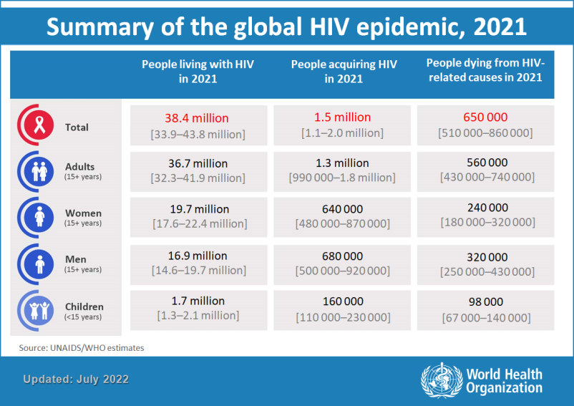
Who are affected most by HIV/AIDS? A UNAIDS report says:
“Evidence shows that HIV prevalence among sex workers is 12 times greater than among the general population. Even in very high prevalence countries, HIV prevalence among sex workers is much higher than among the general population. An analysis of 16 countries in sub-Saharan Africa in 2012 showed a pooled prevalence of more than 37% among sex workers.”⁴
Moreover, not only the sexual workers are more susceptible to HIV than normal women; the men coming into their contact also run much higher risk.
Apart from sex workers, homosexuality is another natural habitat for HIV/AIDS. The United Nations estimates that 2 to 20% of all MSM (men having sex with men) are infected with HIV, depending on the region they live in. The CDC reports that
“In 2009, in United States MSM accounted for 61% of all new HIV infections and that MSM who had a history of recreational drug injection accounted for an additional 3% of new infections. Among the approximately 784,701 people living with an HIV diagnosis, 396,810 (51%) were MSM. About 48% of MSM living with an HIV diagnosis were white, 30% were black, and 19% were Hispanic or Latino. Although the majority of MSM are white, non-whites accounted for 54% of new HIV related MSM infections in 2008.”

A recent study estimated that for every 100,000 MSM, 692 will be diagnosed with HIV. This makes MSM 60 times more likely to catch the virus than other men and 54 times more likely than women.⁵

The obvious reason for this huge difference is the nature of the organs involved in coitus. The HIV virus is more easily transmitted through unprotected anal intercourse than through unprotected vaginal intercourse; and men who indulge in unprotected receptive anal intercourses are at increased risk of contracting the HIV virus. Generally, the receptive partner is at greater risk of contracting the HIV virus; because the lining of the rectum is thin and may allow the virus to enter the body through semen exchange. But the insertive partner is also at risk because STIs can enter through the urethra or through small cuts, abrasions, or open sores on the penis. Moreover, condoms are more likely to break during anal sex than during vaginal sex. Thus, even with a condom, anal sex can be more risky.
The IV drug abuse is also one of the major risk factors and the drug abuse along with promiscuity and/or homosexuality increases the risk multi-fold.

Rabies (Dog Virus)
Another big killer, which has one hundred percent mortality even in this age of advanced medicine, has been Rabies, the dogs being the major carrier followed by some other animals like bats. According to the WHO, the global burden of Rabies is 60000 deaths per year. More than 20000 deaths take place in India alone. Africa accounts for even a greater number. According to “Rabies vaccines: WHO position paper”, Rabies in dogs poses a threat to more than 3.3 billion people in the world⁶.
HPV (Human Papilloma virus)
HPV or Human Papilloma Virus is the most common sexually transmitted infection, which can lead to Cancer or Genital Warts. Cervical Cancer is most commonly linked to HPV, but HPV can also cause Cancer in Vulva, Vagina, Penis, Anus, Mouth, and Throat. According to WHO, in 2020, an estimated 604 000 women were diagnosed with cervical cancer worldwide and about 342 000 women died from the disease. Worldwide, Cervical Cancer is both the fourth most common cause of cancer and deaths from Cancer in women. It is the second-most common cause of female-specific cancer after Breast Cancer, accounting for around 8% of both total Cancer cases and total Cancer deaths in women.⁷
Hepatitis B
Hepatitis B is again a big cause of mortality and morbidity. It is spread through blood transfusion and sexual route, the promiscuous, homosexual and prostitutes being the main victims. The WHO estimates that about 354 million people worldwide live with Hepatitis B or C, and for most, testing and treatment remain beyond reach.⁸

Covid-19
Severe Acute Respiratory Syndrome caused by Corona virus 2 (SARS-CoV-2) was named as COVID-19 by the WHO on the 11th of February 2020. It can cause severe pulmonary infection, respiratory failure; and therefore early diagnosis is crucial.⁹

While unconfirmed theories about Corona virus having originated in Chinese laboratories have been circulating, most health experts believe that the new strain of Corona virus originated in bats or pangolins, the meat of which was sold in animal markets in Wuhan, China. The first animal to human transmission occurred there. Since then, the virus has mostly spread through person-to-person contact. SARS-CoV-2 is an air-borne and fomite-borne disease.

Common symptoms of COVID-19 include: fever, breathlessness, cough, sore throat, headache, muscle pain, chills and loss of taste or smell. These occur 2–14 days after exposure to the virus.

The risk is higher for healthcare workers and patients with Co-morbidities. Older adults are most at risk of severe illness, as are people with serious heart, kidney, pulmonary diseases, obesity, sickle cell disease, weakened immune system and Type 2 Diabetes. The death rate has varied from country to country. It has been very low in India, of about 1-2 %.

Covid has of course been the disease, which has affected the world most in recent times in terms of disrupting the normal life all over the world; because it threatened almost every single person on the planet. As in October 2022, authorities in 227 countries and territories have reported about 630.2 million Covid-19 cases and 6.6 million deaths since China reported its first cases to the World Health Organization (WHO) in December 2019. Further details will be discussed later.¹⁰

Monkeypox
Monkeypox is the latest arrival in the series of recent viral pandemics, which has already sent danger signals to the world. This is a rare disease caused by infection with a virus called the Monkeypox virus because it was first detected in a colony of monkeys in 1958. Monkeypox belongs to the family of Variola virus, the virus that causes Smallpox. Monkeypox symptoms are similar to Smallpox symptoms, but milder, and Monkeypox is rarely fatal. Despite being named “Monkeypox,” the source of the disease remains unknown. The first human case of Monkeypox was recorded in 1970.¹¹ Prior to the latest 2022 outbreak; Monkeypox had been reported mainly in several central and western African countries or those having travelling history to Africa. This time it has already affected several dozen countries.
What has made Monkeypox hit the headlines is that the latest outbreak has mainly affected the people with Male to Male sexual contacts. Here are excerpts from a report:
“….Monkeypox is spread from person to person by close personal contact, according to the WHO. …Males who have sex with men have been recognised in several of the instances reported from non-endemic countries. Sexual health clinics were used to identify these cases. It's possible that the increased reports of Monkeypox cases in communities of men who have sex with men is due to this demographic's positive health seeking behaviour. .. Typical symptoms include fever, headache, muscle ache, backache and fatigue and swollen lymph nodes and then it's followed by skin rashes and or lesions…
“Of the 528 confirmed cases reviewed, 95% are believed to have transmitted during sex between men, according to a new paper in the New England Journal of Medicine. …The global Monkeypox outbreak is primarily being driven by sex between men, according to the first major peer-reviewed paper to analyze a large set of cases of the virus.
…According to another report, while it is not normally fatal but it can cause severe symptoms. “We have seen patients with severe rectal pain that worsens every time they go to the bathroom, genital pain every time they urinate and throat pain every time they swallow,” said Dr. Jason Zucker, an infectious disease specialist at Columbia University Department of Medicine. …In the United States, confirmed cases of Monkeypox have increased dramatically in recent weeks, to 2,593 as of Thursday. With fears mounting among infectious disease experts that the virus will become endemic in the U.S. ...Public health experts also theorize that major LGBTQ Pride gatherings in June may have facilitated transmission of the virus…..All the cases were among men, including one transgender man, 98% of whom identified as gay or bisexual. ..Despite some public health officials, including those at the CDC, cautioning the public about the risk of household transmission of Monkeypox, just three of the 528 cases, or 0.6%, were believed to have been acquired through such means. And just four, or 0.8%, were considered to have transmitted through nonsexual close contact… What’s more, their paper offers strong new evidence that anal sex itself, although not necessarily ejaculation, is a major source of transmission.”¹³

It is clear that almost all these viral diseases have a direct relation with non-compliance with Islamic directives. We will discuss later what these directives are; and how they can be developed into a highly effective Health Protective System for the whole world.

There have been some other viral diseases; but they did not cause much damage. One notable example is SARS or Sub Acute Syndrome Virus which caused around 800 deaths in China in the earlier part of the current century. It is also known to have originated in bats and civets.

3.
Strategies adopted to confront Covid-19
We will specifically focus here on Covid because in recent times no other disease caused such devastation and such paralysis of world life as did Covid 19. There have been a number of strategies adopted in the wake of the spread of Covid-19 pandemic. These include partial or complete lockdowns, other social distancing norms, use of masks and sanitation. Let us discuss how these strategies worked or failed in controlling the menace.

Lockdown strategy
Lockdown has been the most prominent component of the strategy to combat Covid. This has been true for most parts of the world with different countries adopting it in variable intensities in different stages. While countries like China and New Zealand adopted a highly stringent kind of policy, most European countries and United States adopted a low profile approach with the intensity getting lower and lower with every wave. In India too, lockdown strategy was nationally adopted. The Governmental sources try to claim that it has been a big success while the Opposition will try to paint it as failure. The truth is in between the two.

While the lockdown has certainly put some brakes on the spread of the virus and the number of cases and deaths could have been far greater if it was not enforced, the brakes have not been as perfect as they could have been with a better strategy. Where the system failed, is its inability to precede the Lockdown of the country with the Lockdown of the airports at the right time.
India has been fortunate to get the Covid transported to it a little later than many of the countries. It had lot of time to plan. But what the Healthcare system failed to do was to realise at the right time that if at all Indians are going to be infected, it would be through the people coming from outside the country. If the Lockdown had been clamped on the airports right in the first week of March or before, with the quarantine of every single person coming from outside the country, perhaps, the Lockdown would not have been required for the country.
India’s second failure was the strategy related to the details of the various lockdowns. Migrants could have been given 5-7 days’ time to embark on their journeys to their native places. After the first lockdown, the cities where no single case was reported could have been allowed normal activities within the city with complete sealing of the borders. Those coming from outside should have been quarantined before going homes. This could have saved the stress on the economy to a certain extent.
If the death rate was lower in India, than in many countries, it had many reasons apart from the health care. In India, the number of young is much higher than in Western countries. Further, the future studies may show that alcohol played a role in the mortality and despite the rising trend in India too, it is relatively much less common in Indian population than the western countries. It can be noted that after the opening of liquor shops in New Delhi, there was a sudden spurt in the number of daily cases.

“Test, Test and Test”: WHO’s Mantra for Corona for Benefit of Markets
The World Health Organisation has failed in formulating right policies to achieve its stated objective of “highest standards of health” and can very well be called “the Failed Organisation”. The WHO has always acted in a way, which safeguarded the interests of the market forces and their political allies. It has never stressed on natural preventive methods (avoiding/banning harmful substances and practices altogether) and has run huge campaigns for artificial preventive methods involving vaccines and condoms.

In 1980s, HIV/AIDS emerged as a pandemic and reached a dangerous level in 1990s causing death and mayhem across the globe. But the WHO never talked of anything like “sexual distancing” throughout the period despite the scientifically proven facts showing direct relationship between the HIV and promiscuity, prostitution, homosexuality and IV drugs.
At that time, the only slogan of WHO was “Condoms, Condoms and Condoms”. The result was that sex markets continued to prosper, so did the HIV statistics. Consequently, more than 40 million people lost their lives. More than 70 million people are living with HIV to this date while hundreds of thousands die every year.
Once the antiviral therapy against HIV started getting marketed, even the “Condoms, Condoms and Condoms” campaign went into hibernation. The market wants the HIV to continue; because if the problem subsides, both the “cause-of-problem market” as well as the “solution-of-problem market” will nosedive.
With the spread of Covid-19, the WHO was busy raising the “Test, Test and Test” slogan. It failed to call for ban on travel from and to China at the right time and between other countries again at the right time. If travelling from and into Wuhan, then from China and into China had been controlled at the right time, the Covid could not have become a pandemic.
The WHO started sounding alarm over the disease turning into a pandemic as early as in the beginning of January this year. Yet it failed to advise the governments to take steps to stop the entry of Corona in their countries. Why would the WHO come in the way of transport and travel industry?
The irony is that even after the governments world over had imposed severe restrictions on travel within their countries and between different countries, the WHO continued to shout, “Test, Test and Test”. This formula again was going to help the testing kit manufacturing companies.
Though testing was extremely important; but projecting it as the solitary solution only worsened the situation. The WHO was hoping that the anti-Covid vaccines or treatment would soon emerge and then again, like HIV/AIDS, it would soften its alarm against the Covid.
When the system of governance in coalition with the corporate world starts offering dangerous choices to the people in the name of “Freedom of Choice”, the humanity runs the risk of getting ill. There cannot be anything more inhuman than letting the people fall ill because the healthcare industry needs patients and the markets of the causes of the problems need them to continue.

Major Faults in confronting Corona
“Economics First or Health First?” (by Javed Jamil) was released in August 2019. Interestingly, in the early period of covid pandemic, the words of the title became a topic of debate as the Corona pandemic unfolded throughout the world. The debate appeared to be paving the way for an open confrontation between the dedicated classes of scientists on the one hand and the political and economic forces on the other.
When Neil Ferguson, a British scientist who was part of the Government’s Advisory Board on Corona resigned for ignoring the directives on social distancing, there were reports, which suggested that he was fired not due to the stated reason of his meeting his girlfriend, but because of his hard views on scientific strategies which irked the forces. Here are some excerpts from a Guardian report:
‘There is no doubt that Ferguson, who sat on the government’s Scientific Advisory Group for Emergencies (Sage) before his resignation was wrong to ignore the government’s social distancing rules… But today’s lurid front-page headlines follow a campaign to discredit him by those ideologically opposed to government interventions, and who have used such tactics against scientists in other fields, particularly climate change… It is a further sign that some media commentators and politicians favour a version of Britain in which politicians and newspaper editors dictate the public understanding of biology and physics…
“Ferguson has been under attack ever since his research team’s modelling suggested in mid-March that hundreds of thousands of deaths in the UK from Covid-19 were possible if stronger efforts were not made to curb the growing epidemic… Ferguson’s contribution was initially praised, but it was not long before his reputation was under assault from parts of the media traditionally sceptical of a so-called “nanny state”…
“On 28 March, the Daily Telegraph published an article alleging that “the scientist whose calculations about the potentially devastating impact of the corona virus directly led to the countrywide lockdown has been criticised in the past for flawed research”… The next day, Peter Hitchens, in the Mail on Sunday, described the lockdown as “mass house arrest” and identified Ferguson as being “one of those largely responsible for the original panic”.
“A few days later, the Wall Street Journal published an article by two British commentators that argued “the corona virus pandemic has dramatically demonstrated the limits of scientific modelling to predict the future”. It singled out Ferguson’s work and complained that “reasonable people might wonder whether something made with 13-year-old, undocumented computer code should be used to justify shutting down the economy”.
“Many other scientists in the UK working on issues that have implications for government policy know what it is like to be vilified, both publicly and privately, for their findings. They are regularly attacked by many of the British media commentators who are currently joining the pile-on to Ferguson.”
The write-up concludes, “It is time to put a stop to these media lynch mobs that risk driving Britain back into the Dark Ages. We must continue to base our decisions on the advice of experts such as Ferguson and reject the irrational arguments of those who want political dogma to trump evidence.”¹
The COVID-19 outbreak, for some time, forced the world to think of health at the cost of economics. But, soon things started changing.

In India too, first countrywide lockdown was applied for two months, without realizing the fact that at that time it was largely not required in smaller cities and rural area, where there were absolutely no cases by then. It was then opened; and when several months later, the problem started growing in smaller cities, then there was no lockdown there because of economic considerations. While the Lockdown should have continued for some more time in big cities like Delhi, Mumbai and Ahmadabad, the pressure of alcohol industry was too much for the government to withstand. Liquor shops opened in most of the cities, and the currency started flowing. This was of course at the huge risk of the sudden spurt in the cases, as social distancing norms were openly flouted. Other market forces were looking to how Corona pandemic can be used to benefit the healthcare industry. There is hardly any surprise that soon India occupied the second position in the world in the number of cases.

Here is an excerpt from an article:
“As previously happened in the case of HIV/AIDS pandemic, all hullabaloos will remain only till the vaccines or treatment is found. Once the vaccines are found, there will be an attempt to sell it as much as possible, and social distancing norms will die. Once treatment is found, even vaccines will be forgotten, because if people do not fall ill, how will the Healthcare industries prosper?”²

And this has proved right. As soon as the vaccines started reaching the masses, the curbs on social distancing started getting loosened.

While, by the beginning of the second half, most of the developed countries of the world had shifted their focus from saving the lives to saving the economy, the Chinese Government still insisted on Zero Covid policy; and interestingly it did not only lead to protests within China, it also attracted huge criticism from the Western world. They forgot that, while after initial few months when China lost around 5000 people due to covid, there were not even one thousand more deaths, America and European countries millions of lives, more than 1 million in America alone. While China cared for the lives, West cared for the dollars. This becomes even more interesting considering the fact that China was initially severely criticised for the origin of Corona Virus, and many even argued that it was deliberate. When the protests and the world pressure increased and China stopped its Zero-Covid policy loosening restrictions, within a fortnight there was massive surge of Covid cases. And interestingly, now the world was attacking China for not providing the true statistics of deaths. While the international world may have reasons to remain wary of China due to ideological reasons, and India may have its own reasons to be angry with China, China’s control of Covid should have been appreciated. But again the world was caring more for economics than the lives of the people. The world media and the organisations will hardly lament the deaths of more than 65 million human beings; it is always busy to count how many dollars were lost in business.

4.
Long-Term War against Viral Pandemics: Islamic Arsenals
Since the rise of the Last Prophet of Islam Muhammad (Peace be upon him!) in the early Seventh Century, the world has faced many epidemics and pandemics. The more known epidemics include the Black Death (1346- 1353), Cocoliztli epidemic (1545-1548), American plagues (16th century), Great Plague of London (1665-1666), Russian plague (1770-1772) and Flu pandemic (889- 1890).¹ But perhaps the most devastating pandemics of the modern world have been Spanish Flu and HIV/AIDS. Spanish Flu caused by HIN1–believed by most if not all scientists to have originated in pigs–in 1918 affected one third of the world’s population and according to various reports, killed 20-50 million people.² The second most devastating pandemic has been HIV/AIDs, which in the last 30 years has affected more than 75 million people and killed more than 40 million. More than 38 million people are still living with HIV. ³ Initially, promotion of prophylactics and safe blood transfusion were used as the standard methods to contain it. Now, anti-HIV drugs are being used and it is helping to increase the life expectancy of the patients. But in March 2020, only second patient is known to have been declared “cured” of HIV⁴.Then, there were other swine flu epidemics in the first decade of the 21st century in America and some other countries. The Corona pandemic may not ultimately prove to be as big a killer as Swine Flu and HIV/AIDs, but it is unique in the sense that unlike other pandemics, it has affected almost every country in the world, and almost everybody felt threatened by it. Then there have been Human Papilloma Virus (HPV) and related Cancer Cervix (common in uncircumcised communities), Hepatitis-B and Rabies, every one of which has been a big killer.
It can be seen that almost all viral outbreaks in the last 120 years have had direct relationship with Islamic guidelines. If pork had been banned worldwide, more than 80 million people would not have met premature deaths due to Swine flu; had there been strict laws in force against promiscuity, prostitution and homosexuality, around 40 million lives would not have been lost due to HIV/AIDS millions of women would not have died of HPV-related Carcinoma Cervix, had circumcision been a worldwide ritual in addition to sexual hygiene prescribed by Islam; had dogs not been allowed in residential areas, millions again would not have succumbed to Rabies, and millions of people would also not have lost their lives to Hepatitis B (spread through blood transfusion and sexual route). In addition to this, had alcohol been made totally illegal, hundreds of millions of lives would not have succumbed prematurely to various diseases, accidents and crimes related to drinking, in the last 50 years. In the wake of COVID-19 outbreak, China has imposed ban on the meat of wild animals, specifically lions, bats, snakes and pangolins. The meat of all these animals is not permitted in Islam.
Furthermore, if just one saying (Hadeeth) of Prophet Muhammad (Peace be upon him) had been followed right in the beginning in China’s Wuhan, Covid-19 would not have become a pandemic. The Hadeeth says: ‘If you hear about it (an outbreak of plague/or any epidemic) in a land, do not go to it; but if the plague breaks out in a country where you are staying, do not run away from it”. (Sahih Bukhari)⁵ Had Chinese officials banned travelling from and to Wuhan, Corona could not have moved out of that city. And once it began spreading to other countries, had travelling between countries been severely restricted and none allowed to enter a country without being quarantined, the disease would not have become so widespread. But the world response to the threat was slow, because they were more interested in preserving Economics, and they resorted to stringent measures only when they felt that corona has the potential to devastate in a big way, and it would spell a bigger economic disaster, if it is not contained.
Practices that help viruses emerge
Let us have a list of the practices that help different viruses emerge:
- Swine flu: pig farming necessitated by pork eating
- HIV/AIDS: Promiscuity, homosexuality and prostitution; IV Drugs (Alcohol contributing factor)
- Rabies: dog bite (domestication and permission of dogs in residential localities)
- Hepatitis B: blood transfusion and sexual route (Promiscuity, homosexuality and prostitution) Alcohol and Drugs contributing factor
- HPV: sexual perversions, lack of urogenital hygiene (More common in uncircumcised population and women in their contacts), Alcohol and Drugs contributing factor
- Monkeypox: Promiscuity, homosexuality (Most common cause)
Islamic Guidelines that prevent viruses
Now let us enlist the Islamic Guidelines that prevent viral infections. These are:
- Prohibition on pork;
- Total Prohibition on promiscuity, homosexuality and prostitution;
- Urogenital and sexual hygiene;
- Prohibition on alcohol and drugs;
- General hygiene;
- Discouragement against dogs in houses and localities;
- Quarantine in epidemics: Neither go to the affected areas nor out of it;
Islamic position is clear. It permits “Tayyab” (healthy) things and prohibits “Khabeeth” (dangerous) ones. It warns against those practices that can kill. See the following verses from Qur’ān:

“...the one who promotes the well-recognised (actions) and campaigns against the Unacceptable, permits them what is healthy and prohibits what is unhealthy, and rescues them from their heavy burdens and the shackles that grip them. It is they who are truly committed to him, honour and help him and follow the Light which has been dispatched to accompany him. They are the true achievers.” (7: 157)⁶

“This day all healthy foods are made lawful to you.⁷” (5: 5)

“Except the mentioned ones, all the others are lawful to you on the condition that you seek (marriage with) them in return of assets, for a healthy relationship, not for temporary pleasure....”⁸ (4: 24)

“Items prohibited for you are: the meat of the dead (animals), blood, the pork, the meat which has been dedicated to a deity other than God, the flesh of the animals killed by strangulation, or by a violent blow, or by a fall on the head side, or by being gored, or left after hunting by a wild animal, unless you are able to properly slaughter it, or (that of an animal) sacrificed at altars. Further, taking decisions through divination of arrows is a gross violation (of the code).”⁹ (5: 3)

“They ask you about the substances of addiction and gambling. State: "There is huge sin and some benefits for the mankind in them; but the sin is much greater than their benefits." (2: 219)”¹⁰

“State: My Lord has prohibited nothing but the illicit relationships, open as well as secret, the (known) sins and the unauthenticated violations.” (7: 33)¹¹

Apart from the practices declared prohibited, Islam also stresses general hygiene in a big way stressing washing of private parts after each urination and intercourse and recurrent washing of hands apart from washing of exposed parts (face, hands, forearms, and foot) five times a day before each compulsory prayer.

Circumcision a potent weapon against viruses and bacteria
Circumcision is becoming increasingly popular due to the evidence accumulating that it has a very strong protective effect against all sex transmitted diseases including AIDS as well as HPV related Cervical Cancer. A report from Africa says:
“As hospital wards overflow, avoiding HIV has become a consuming concern for Swazis. Since the South African report appeared saying that circumcised men are 60 percent less likely to contract HIV, the shift in Swazi attitudes toward circumcision -- once widely viewed as unmanly -- has been dramatic and swift….Hospitals that once rarely performed circumcisions have recently been doing 10 to 15 a week, with two-month waiting lists. A physician with a radio show has called on his listeners to have the surgery, which removes the foreskin and along with it the cells most vulnerable to HIV. A lawmaker has advocated the procedure in a speech to parliament and demanded that the government increase capacity and subsidies for it…..The South African study was the first to experimentally test the effectiveness of circumcision in preventing HIV, but dozens of studies have shown that infection rates are far higher in regions with low circumcision rate”.¹²
The Scientific fraternity is usually not sympathetic towards religion. There have been attempts in the past to disregard the beneficial effects of circumcision. But the greater numbers of medical experts have argued in favour than those against it. In the US, circumcision enjoyed great popularity in the last century. But after 1999, when the American Academy of Paediatrics issued a policy statement saying the potential medical benefits of neonatal circumcision weren't strong enough to recommend it as a routine procedure, the popularity declined. The group shifted its stance however again recently saying newer studies indicate the health benefits of circumcision do outweigh the risks and that parents should be told of its protective effects.
Ronald Gray, a Physician and Professor in the Johns Hopkins Bloomberg School of Public Health, makes the case in favour of neonatal circumcision. Here are a few excerpts from his article,” Yes: The Benefits Are Many, While the Risks Are Few”¹³:
“The health benefits of newborn male circumcision outweigh the risks, and the procedure should be accessible to all families who want it. So said a task force convened by the American Academy of Paediatrics to review the latest scientific evidence on circumcision and update the group's policy stance…Here are the facts, based on published, peer-reviewed and independently monitored studies
“The risk of complications from newborn circumcision in U.S. hospitals is estimated to be about 0.2%. The most common complication is bleeding, which can be readily controlled. Infection and penile injuries are very rare…..The benefits of circumcision that accrue during childhood include a marked reduction in urinary-tract infections, which affect one in 100 uncircumcised boys, mainly during the first two years of life, and inflammation or infection under the foreskin, which affects around 17 in 100 uncircumcised boys before the age of 8. Circumcision reduces the risk of these problems by around 60%. In adulthood, circumcision has been shown to reduce the risk of HIV infection in men by 50% to 60%, and is now recommended by the World Health Organization as an HIV prevention strategy…….Circumcision also lowers the risk of acquiring herpes infection and genital ulcers in men. It reduces infection with human papilloma viruses, or HPV, in both men and their female partners. HPV is one of the most common sexually transmitted infections in the U.S., causing cervical, penile and anal cancers and genital warts. Female partners of circumcised men have lower rates of vaginal infections and genital ulcers…… Circumcision doesn't impair sexual potency or pleasure, according to randomized controlled trials. These studies are considered the most credible because they compare men who are circumcised at random versus men who aren't, and the men who are circumcised during the trial can assess whether their pleasure or potency is affected by the procedure.
In short, infant male circumcision has lifelong health benefits that outweigh the immediate risks, and parents should be counselled so they can decide what is best for their child.”
According to reports, in 2007, the WHO reviewed the totality of evidence concerning male circumcision and HIV, and issued the following joint recommendations with UNAIDS.¹⁴
- Male circumcision should now be recognized as an efficacious intervention for HIV prevention.
- Promoting male circumcision should be recognized as an additional, important strategy for the prevention of heterosexually acquired HIV infection in men.
- Circumcision should only be performed after informed consent.
Kim Dickson, coordinator of the working group that authored the report, commented:
- Male circumcision "would have greatest impact" in countries where the HIV infection rate among heterosexual males is greater than 15 percent and fewer than 20 percent of males are circumcised.
- WHO further recommends that the procedure must be done by a trained health care professional.¹⁵
Incidentally, one of the authors of this book, Dr. Javed Jamil had proposed the inclusion of circumcision in AIDS control programme way back in 1996 in his book, “Islamic Model for Control of AIDS” It was much later that the WHO adopted it.
Finally, coming to the religious angle, it cannot be without significance that the practice of circumcision was started by Abraham (Ibrahim in Arabic, PBUH), the revered Prophet of Jews, Christians and Muslims; and there must have been more to it than a sheer coincidence that this was done at a time when Sodom and Gomorrah had become the hotbed of homosexuality and were subsequently destroyed by God.
Other Preventive Methods
If the all-out war against viruses and other infections has to be waged, Islamic steps involving Primary Prevention will have to be taken. These include:

- Istanja (Washing of private parts after urinating), which has huge protective effects against the urogenital infection;
- Wudu (Ablution), which involves washing of the exposed organs and mouth (including use of miswak for brushing) reducing the risks of mouth infections, cardiovascular problems, skin infections and cancers and eye infections;
- Washing of private parts after intercourse and bathing as soon as possible; which will decrease the chances of sex related diseases;
- Total ban on premarital, extramarital sex and promiscuity, homosexuality and prostitution, which all are the leading factors responsible for propagation of various sex related disorders including Syphilis, Gonorrhoea, Herpes, Reiter’s disease, HIV/AIDS, HPV and related Cancer Cervix, and Hepatitis B infection; (The last is not generally included in sex related diseases but has sexual route as one of the most common modes of spread.)
- Avoidance of sex during menses, which again prevents from urogenital infections;
- A compulsory period of Iddah (waiting period) between two marriage partners, which again is very important in preventing sex transmitted diseases. This will be elaborated later;
- Total ban on the production, serving and use of alcoholic beverages, which will not only prevent diseases like Cirrhosis, several cancers and Psychosis but will also help in prevention of sex related diseases and impotence and alcohol related accidents, crimes and suicides;
- Circumcision that prevents from Phimosis, Paraphimosis, sex-transmitted diseases including AIDS and the Cancer of Cervix (among women)
- Miswak (Brushing of teeth), which has a remarkable preventive effect on the infective diseases of teeth, gums and several internal organs, is also a part of secondary prevention;
- Ban on Pork and pig farming, which will stop Swine Flu from spreading;
- Discouragement of` keeping dogs in houses and near vicinity; which will drastically reduce the incidence of Rabies;
- Covering nose and mouth while sneezing and coughing; which will help in stopping infection from spreading.

It appears from one Hadith that pigs will become such a big source of trouble in future that Jesus, at the time of his Second Advent, will order the killing of all the pigs. Abu Hurayra, RA, narrates that Rasulullah (SAW) said, 'By him in whose hand my soul is, surely the son of Mary will come down among you as a just ruler. He will break the cross, kill the pigs and abolish the Jizyah.'¹⁶
There is nothing known yet about the real origin of this Corona virus, but it may ultimately prove to have originated through contact with some wild animal. In Islam, hunting animals for entertainment and gambling is strictly prohibited, and the emphasis on eating the meat of only certain permitted variety of domestic animals and certain fishes and birds.
In short, pigs, dogs, promiscuity, prostitution and homosexuality have been the biggest breeding grounds for the spread of the killer viral diseases. If prevention against infections in general and viral infections in particular has to be successfully achieved, ban on pork eating and pig farming and domestication of dogs and an effective campaign against prostitution, promiscuity and homosexuality will have to be ensured. Alcohol and drugs have clear relationship with many of these practices and subsequently the death caused by these. These have no place in any civilised society, which cares for life, healthiness of life, family and social peace. Apart from banning alcohol, circumcision needs to be popularized at the war footing.

Medical significance of Iddah
Let us understand the significance of Iddah, usually translated as the Waiting Period. Iddah is the period for which a woman has to wait after the initiation of the process of divorce or after the death of her husband. She is not allowed to marry again before the expiry of the period. Technically, Iddah is understood to be a woman-specific provision, but practically it also binds a man unless he intends to have a second wife, because the responsibility to maintain the divorced woman during Iddah including a compulsory permission to allow her stay in his house as before, is that of husband. In fact, the divorce becomes functional only after the expiry of Iddah. The following facts about Iddah are to be noted:
- In case it follows the pronouncement of divorce, the period of Iddah is three menstruation-cycles if by that time she shows no signs of pregnancy.
- If a woman undergoing Iddah develops the signs of pregnancy her Iddah will be extended till the termination of the process of delivery. (This must ideally include the postnatal period of 40 days because it is the total period of antenatal, natal and postnatal period which clearly appears to comprise the “burden” mentioned in the Qur’an.)
- If she is having irregular or no menstruation cycles, her Iddah will be of three months.
- If she is undergoing Iddah after the death of her husband, its duration will be four months and ten days.

The legal provision of Iddah has enormous implications on family and social health and legal matters related to marriage.
- Iddah safeguards the honour of woman. If a woman leaves the house of her husband, and after a few weeks she develops the signs of pregnancy, the possibility of her husband charging her with infidelity cannot be ruled out.
- Iddah safeguards the legal rights of woman and her child. In case, Iddah is not completed in the husband’s house, the paternity of her foetus may become a matter of controversy. Till a few decades back, there was no way of arriving at the right conclusion about the father if child.
- Iddah ensures safe motherhood. In case her pregnancy is completed in any house other than that of her husband, she may suffer from mental anguish, which can be detrimental for the health of mother and child. If she has to suddenly leave the house in the early periods of pregnancy and has no safe place to go, this may cause severe distress to the mother and child. If she develops complications, again she may find herself in a distressful situation.
- In the case of divorce (according to the procedure laid down by Qur’an), Iddah provides an opportunity to the couple to bury their differences and reunite without any problem.
- Iddah is also extremely important for the sexual health of individuals and society.

It was in 1996 when the first author of this work published, “Islamic Model for Control of AIDS” in which he discovered that Iddah would play a crucial role in protecting men and women from sexually transmitted diseases. One of the primary objectives of Iddah is to ensure that, right from the first day of conception till the completion of the process of delivery (including postnatal period), she would be looked after financially, physically as well as socially by her husband. During this period, the husband is not entitled to formalise the divorce even if he has decided to part with her. In effect therefore, the antenatal, natal and postnatal cares are obligations imposed by Islam on fathers. This also provides the couple with an opportunity to reconcile their differences; the revelation that she is pregnant is more often than not likely to facilitate reconciliation. It is obvious that such an extraordinary status of mother also ensures the safety of the child.

Family is not an artificial creation of man, because every born human has a father and a mother. It is therefore necessary that the parentage of every child must be established beyond doubt. The establishment of the identity of mother is a foregone conclusion, as she physically delivers the child (except if she is a surrogate mother). But the establishment of the identity of father will create huge problems if the propriety of the institution of marriage is not maintained. If there had been no provision of a mandatory period of waiting, it would have become impossible, in case a woman married within a few days of separating from her husband, to know the real father, except through DNA testing, which is only a recent addition and is still not easily affordable in many parts of the world. If the identity of the father of the child is not established, it is bound to cause immense damage to the future prospects of the child; he or she may have to grow outside the shadow of fatherly protection. In short, Iddah preserves the family system ensuring that the children and parents live without their mutual love and affection getting diluted by any kind of suspicion. This of course also preserves the credibility and honour of the woman. A large number of studies have shown beyond doubt that children grow best when their natural parents are living together and with them.

Another important role of Iddah is to prevent the sexually transmitted diseases. The provision of Iddah means that no woman can ever have sexual relations with two men without a gap of a minimum period of three months. This is greatly helpful in minimising the risks of HIV and other STDs. It is interesting to note that the incubation period of all the STDs (except HIV) is less than 90 days, and the window period of HIV/AIDS is also about 90 days. Incubation period refers to the time lag between the entry of an infective organism in the body and the appearance of first signs of the disease. Window Period is the time lag between the entry of the organism and the appearance of the signs of the disease in specific blood tests. In Syphilis for example, the median period of incubation is 21 days though occasionally it may be up to 90 days. Here are excerpts from an article by Elizabeth Bosky¹⁷ on the incubation period of STDs:
Chlamydia: “usually one to three weeks”
Gonorrhoea: “as early as two days after exposure, or as long as one month”
Syphilis: “between 10 to 90 days”
Chancroid: “within five to seven days”
Trichomoniasis: “between 5 to 28 days”
Scabies: “one to two months”
Genital warts: “within 3 months”
Genital Herpes: “within two weeks”
HIV: “most infected people will test positive within 3 months”

So, in the case of Syphilis, the woman will develop symptoms of Syphilis within and not more than three months. The development of a painful swelling in her private parts is likely to prevent her from marrying till she gets relieved. The same is true of other STDs like Lymphogranuloma venereum, Reiter’s disease, Herpes etc. In the case of AIDS, while the incubation period may be several years, the blood test for HIV becomes positive within three months. The vast majority of people have detectable antibodies by three months after HIV infection¹⁸; a six-month window is extremely rare with modern antibody testing. So if the spread of AIDS warrants a strict vigilance a woman may get her HIV tested after the expiry of Iddah before getting married again. This rule may be used with good effect for the AIDS prevention programmes. This will be explained in more detail shortly.

Islamic Model for Control of AIDS and other STDS
Our attitude towards sex and sexuality is to be governed by the trio of individual health, family peace and social order. Sex is a normal desire. It has to be one of the strengths not the weaknesses of human souls. Controlled sex is the harbinger of life; uninhibited sex that of death. Controlled sex heralds peace and health; uninhibited sex chaos and disease. Controlled sex brings lasting happiness; uninhibited sex temporary pleasure. Controlled sex builds and safeguards family, which uninhibited sex destroys. Controlled sex is benevolent on women and children; uninhibited sex decimates them. Controlled sex depicts accountability and responsibility; uninhibited sex lawlessness and irresponsibility. Uninhibited sex seeks to exploit humans; controlled sex endeavours to prevent it. Controlled sex transforms men into humans; uninhibited sex turns them into beasts. Finally, controlled sex is the symbol of civilisation; uninhibited sex is the sign of barbarism. If any system promotes sex outside marriage, it has no scientific right to claim itself as civilised. Within the boundaries of family, sex can always be enjoyed in a hygienic way to the maximum, to the highest state of ecstatic love. Outside its boundaries, all forms of sex are unhygienic, whatever precautionary steps taken to maintain relative hygiene.

Outlines of Comprehensive Programme for Control of AIDS

Total Sexual Hygiene
First Line of Defence:
- Male circumcision
Second Line of defence:
- No drugs
- Sex only inside marriage (male-female)
- No anal sex; oral coitus (ejaculation inside mouth) to be avoided
- No sex during menstruation periods and postnatal period
Third Line of Defence:
- Use of condoms whenever suspicion of catching infection
Fourth Line of Defence
- Washing of private parts after intercourse
Fifth Line of Defence:
- Avoidance of corrupting influences

Strengthening of Family System
- Marriages (only male-female) to be promoted; laws to be suitably amended
- Premarital and extramarital sex to be actively discouraged and punished
- Late marriages to be discouraged
- Promiscuity to be suppressed
- Moral and family values to be strengthened
III. Concerted and effective campaign against commercialisation of sex
- Total ban on prostitution and rehabilitation of prostitutes
- Total ban on all forms of pornography
- Campaign against nudity and obscenity in public
- Cleansing of tourism
- Effective and concerted campaign against alcohol and drugs

Medical measures: Sexual quarantine
(These measures are already there in the AIDS control programmes, and should be followed, as they are not contrary to the Islamic injunctions and spirit of safeguarding human beings against death and diseases and use of all preventive and curative methods against diseases. The same is true of legal measures.)
- Proper screening of blood
- Sterilisation of syringes
- Effective sexual (not social) isolation of HIV positive persons: HIV status of a person to be informed to marriage-partners (present and future), boy/girlfriends, clients
- Legal Measures
- Right to divorce if one’s spouse tests positive
- Right to refuse intercourse if her husband does not take adequate measures to safeguard her from the threat of AIDS
- Active measures (including sterilisation) to avoid pregnancy in an HIV positive woman
- Right to know each other’s HIV status before or at the time of marriage

Condoms: limited use only
As has been elaborated earlier, safe sex is only a ploy to perpetuate commercial sex and the free sex it promotes. Safe sex is not safe enough. The effectiveness of condoms in preventing sex transmitted diseases and AIDS is high only if it is used properly and constantly. The failure rate of condoms as contraceptives is as high as 12%. The size of HIV is much smaller than sperms, and their probability of crossing the barrier is quite high. Furthermore, it is used by less than half of the men even in those countries where the level of awareness is substantially high. Sex workers cannot insist on the use of condom, as they risk losing business. The promotion of safe sex is in fact counterproductive. It often tends to ensure a false sense of guarantee against HIV. Adolescents feel inclined to explore sexual liaisons thinking that by using condom they would protect themselves. Condom promotion can however be continued as an additional measure.

The Islamic Model is effective in preventing not only HIV but all other STDs including HPV and Cancer Cervix related to HPV.

5.
Fundamental Prohibitions:
Health Protective Measures

Islamic system is three-dimensional comprising Fundamental Duties, Fundamental Rights and Fundamental Prohibitions. While each category is important from the point of view of holistic health, Fundamental Prohibitions assume extraordinary importance, as they safeguard humanity against the dangerous impacts of certain practices and substances on health.

- Drinking and gambling
The Holy Qur’an says:
- They ask you about the substances of addiction and gambling. State: "There is major sin and minor benefits for the mankind in them; but the sin is much bigger their benefits." (2: 219)
- People Committed (to Islam)! Substances of addiction, gambling and sacrifices of stones (altars) and (divination) by arrows are dirty Satanic practices¹. Hence, keep away from them so that you may become successful. Certainly, through substances of addiction and gambling, Satan's intention is to promote hostility and envy among you people and to create obstacles in your Meditation of God and attending Blessings (Salah). (5: 90-91)
Islam expressly prohibits alcoholic drinks and all the substances causing addiction. In fact Qur’an declares intoxication and gambling as the Devil’s handiwork meaning that those who indulge in these acts in any way are the rebels of God. Prohibition in Islam means prohibition on manufacturing, storing, selling, drinking or serving all the intoxicants including alcoholic beverages and other addicting substances anywhere on any occasion to anybody. Drinking has been labelled as Ummul Khhabaith, meaning “the mother of all evils”, in the Prophetic traditions, and the investigations have clearly established that drinking is Ummul Khhabaith indeed.

Dependence on alcohol is counted as a disease in medical sciences, commonly referred to as Alcoholism. Alcoholism is divided into two groups: substance-use disorders and substance-induced orders. The former include dependence and abuse; the latter include intoxication, withdrawal, delirium, dementia, amnesiac disorder, psychotic disorder, mood disorder, anxiety disorder, sexual dysfunction, and sleep disorder. Alcohol dependence and abuse are manifested by tolerance, withdrawal, inability to fulfil role obligations, recurrent substance related legal problems and social and interpersonal problems. Alcohol can lead to several other diseases. Cirrhosis is a disease related to alcohol that more often than not proves fatal. It is among the leading killers in many countries where alcohol consumption is high. Other medical conditions related to alcohol include cancers (liver and laryngeal), heart diseases, maternal and child health problem (low birth weight and spontaneous abortion), injuries (falls, burns, or work-related), accidents (water and auto transport) and violence (suicide, assault and child abuse). Alcohol is also related to traffic accidents, increased risks of all sex-transmitted diseases including AIDS and suicides. In women, it is related to several cancers like those of breast and liver. Maternal consumption during pregnancy increases the risk of birth defects in children. It is linked to the birth of children with Foetal Alcohol Syndrome. In several countries, FAS is considered to be the most important cause of mental retardation.

There have been several brazen attempts recently to popularise drinking on the basis of some dubious reports that impart a protective effect to alcohol for Ischaemic Heart Diseases. This has been strongly countered by independent experts. It will be worthwhile to quote here from a report:
“Over the past decade seemingly paradoxical evidence has emerged that alcohol consumption may have a protective effect on one aspect of human health: coronary heart disease. Studies have shown that individuals who consume small to moderate amounts of alcohol are less likely to have a myocardial infarction than those who do not drink. (For a review of the studies in the United States on the health benefits of alcohol, see NIAAA, 2000). These studies, however, have been challenged on two fronts: applicability of the findings to women; and methodology (see detailed discussion in World Bank Group, 2000). The majority of participants in the studies were men. In those where women did participate, the protective relationship was not so clear. Studies found that light consumption of alcohol (1.5 to 29.9 grams per day) protected older women (50 years of age and over) from CHD; light consumption also conferred protective benefits on women with one or more risk factors for CHD. These benefits did not hold true, however, for women with no CHD risk factors. Such women enjoyed no significant protective effects. Notably, women who drank more than 30 grams per day had significantly higher mortality, largely due to their higher risk of death from breast cancer. The research on beneficial effects of alcohol remains inconclusive for women. Furthermore, when discussing the beneficial effects of alcohol on the risk of CHD, it is important not to ignore the prevalence of CHD in a given developing country in relation to other health and social problems that are caused or exacerbated by alcohol. 5NIAAA (2000) has conducted an extensive review and analysis of FAS prevention research. Although research is largely US-based, the review offers a valuable framework for developing prevention programs.”¹

It can be safely concluded that if some benefits -- which even Qur’an accepts -- may be accrued to the use of alcohol they will have to be weighed against harms and hazards related to alcohol, which are massive, qualitatively as well as quantitatively, and are enough for its being declared the “Devil’s handiwork”.

Alcohol increases the risks of unhealthy sexual behaviour including almost all viral pandemics. Studies of AIDS in other countries, such as Thailand, indicate that alcohol consumption influences many dimensions of sexual behaviour. One such study, which included students, soldiers and clerks, revealed that “heavy drinking increased the odds of having had sexual intercourse; increased the odds of having visited prostitutes; and decreased the odds of consistent condom use in sexual encounters with sex workers (Van Landingham and others, 1993)².”

The alcohol consumption is directly associated with increased health risks related to alcohol, crimes, accidents, sex-related problems, suicides and domestic violence. According to WHO, “Worldwide, 3 million deaths every year result from harmful use of alcohol. This represents 5.3% of all deaths. Overall, 5.1% of the global burden of disease and injury is attributable to alcohol, as measured in disability-adjusted life years (DALYs)³

Top countries in terms of alcohol consumption⁴
- Czechia - 14.26
- Latvia - 13.19
- Moldova - 12.85
- Germany - 12.79
- Lithuania - 12.78
- Ireland - 12.75
- Spain - 12.67
- Uganda - 12.48
- Bulgaria - 12.46
- Luxembourg - 12.45

Top 10 Countries with the Lowest Alcohol Consumption in 2019 (in litres of pure alcohol per capita):
- Somalia, Bangladesh, Kuwait, Mauritania, Saudi Arabia (5-way tie) - 0.00
- Afghanistan - 0.013
- Libya - 0.027
- Yemen - 0.034
- Egypt - 0.14
- Syrian Arab Republic - 0.19
- Bhutan - 0.21
- Indonesia - 0.22
- Pakistan - 0.31
- Djibouti - 0.36

It can be seen that the biggest alcohol consuming countries are all countries with low Muslim population including many Western countries. In contrast, almost all the countries with lowest consumption rate are Muslim countries. The high consumption rate, it may be argued, points to their high lifestyle and the ability to spend more. If the ability to spend more leads to spending on the purchase of slow poisons for themselves it is better not to be rich. If Westerners consume alcohol at such an alarming rate it is because they have been made habitual or addict of drinking by their cultural supervisors, the forces of globalisation. Moreover, many Muslim countries in the list are those that have one of the highest Per Capita Income in the world; and if still the consumption is low, it tells about the highly positive effect of Islam.
When the alcohol consumption is so high in the world, it is not surprising that about 3 million deaths every year are attributable to alcohol-related problems. A substantial percentage of these deaths occur in the developed nations whose “advanced” health system is always busy in creating conditions that lead to the longevity of life. Still, they are not in a position to demand a ban on substances and practices that are the leading causes of mortality and morbidity.
It is clear that the consumption of alcohol is least (though not absent, which should ideally have been the case) among Muslims and also therefore all the problems related to alcohol—alcohol related diseases, deaths, accidents, suicides, divorces, separations, unhealthy sexual behaviours, rapes, murders etc.
Apart from alcohol, the other drugs too cause huge problems. According to UNODP World drug report, around 275 million people used drugs worldwide in the year 2020, while over 36 million people suffered from drug use disorders⁵. Suicides related to drug abuse amount to a big chunk of all suicides.

Gambling
Let us now concentrate on gambling, which too has been prohibited by Qur’an and along with Alcohol has been described as one of the mischievous activities of the Devil. The habit of gambling is recognised by medical scientists as a disease, which is called Pathological Gambling. According to the National Research Council, “pathological gamblers ‘engage in destructive behaviours: they commit crimes, they run up large debts, they damage relationships with family and friends, and they kill themselves. With the increased availability of gambling and new gambling technologies, pathological gambling has the potential to become even more widespread'"(p. 4-1)⁶. The National Research Council of US states that “many families of pathological gamblers suffer from a variety of financial, physical, and emotional problems, including divorce, domestic violence, child abuse and neglect, and a range of problems stemming from the severe financial hardship that commonly results from problem and pathological gambling. Children of compulsive gamblers are more likely to engage in delinquent behaviours such as smoking, drinking, and using drugs, and have an increased risk of developing problem or pathological gambling themselves.” Other problems include crime, loss of employment and bankruptcy. NRC report adds, 'As access to money becomes more limited, gamblers often resort to crime in order to pay debts, appease bookies, maintain appearances, and garner more money to gamble.' It has been found that “28 percent of pathological gamblers attending Gamblers Anonymous reported either that they had filed for bankruptcy or reported debts of $75,000 to $150,000.'” (Ladouceur et al. (1994))⁷.

The social problems due to gambling are even severer. Relatives, friends and employers suffer hugely. Employers complain of loss of work hours, embezzlement and inability to fulfil their financial obligations. NRC report further states: "How can we begin to measure the social impact of individuals who spend their children's milk money or cash their welfare checks to buy lottery tickets, as the Commission heard during visits to convenience stores? We cannot, but the Commission can acknowledge that when gambling is promoted as 'the only way to get ahead' and, in particular, targets those who do not have 'leisure dollars' to spend, the economic and social, indeed, the moral fabric of our nation is damaged.” (p. 7-18) Reports say that one in fifth of gamblers attempt suicide; other reports speak of as high as two third contemplating suicide.

The impact on family is equally dangerous. In NORC's survey, 53.5 percent of identified pathological gamblers reported having been divorced, versus 18.2 percent of non-gamblers and 29.8 percent of low-risk gamblers. Further NORC respondents representing two million adults identified a spouse's gambling as a significant factor in a prior divorce. In a survey of nearly 400 Gamblers Anonymous members, 18 percent reported experiencing a gambling-related divorce. Another 10 percent said they were separated as a direct consequence of their gambling. The domestic violence and child abuse are significantly greater problems in the families of gamblers than non-gamblers. Several cases of children dying in cars have been reported, on account of their father or mother leaving them locked and forgetting them, as they joined the casino.

Gambling was always bad. History is replete with the havoc caused by gambling in social lives. With the growth of economic fundamentalism, gambling, like other human addictions, became an organised business at the global level. Owing to the money involved in it, market forces were quick to use it as a big money-spinner. Not only have casinos burgeoned, gambling of one kind or the other has also become associated with almost all the vistas of business to accelerate their growth. Casinos are a regular part of tourism and entertainment industry. Betting is associated with almost all the big fixtures including political, entertainment and sports events. Lucky draws are being used to collect money as well as to boost the sales of hosts of consumer items. The globalisation of gambling also means globalisation of opportunities. The National Opinion Research Centre (NORC) of US has rightly stated that
"As the opportunities for gambling become more commonplace, it appears likely that the number of people who will develop gambling problems also will increase.”
Let us note a few facts about gambling:
- NORC found that the presence of a gambling facility within 50 miles roughly doubles the prevalence of problem and pathological gamblers.
- Two key studies indicated that between 15 and 20 million Americans are displaying some signs of a gambling addiction. Further, the Commission emphasised that estimates of the number of problem and pathological gamblers may be significantly understated.
- A Harvard University meta-analysis concluded that approximately 1.6 percent, or 3.2 million, of the American adult population are pathological gamblers. . In Oregon, the lifetime prevalence of problem and pathological gambling is 4.9 percent. Recent studies in Mississippi and Louisiana indicate that 7 percent of adults in these states have been classified as problem or pathological gamblers.
- NORC found that approximately 2.5 million adults are pathological gamblers. Another three million of the adult population are problem gamblers. Over 15 million Americans were identified as at-risk gamblers.
- A survey of nearly 400 Gamblers Anonymous members revealed that two-thirds had contemplated suicide, 47 percent had a definite plan to kill themselves, and 77 percent stated that they have wanted to die.
- In NORC's survey, 53.5 percent of identified pathological gamblers reported having been divorced, versus 18.2 percent of non-gamblers and 29.8 percent of low-risk gamblers. Further NORC respondents representing two million adults identified a spouse's gambling as a significant factor in a prior divorce.
- One domestic violence counsellor from Harrison County, Mississippi, testified that a shelter there reported a 300 percent increase in the number of requests for domestic abuse intervention after the arrival of casinos.
- The NRC reported on two studies indicating between 10 and 17 percent of children of compulsive gamblers had been abused.⁸

According to WHO reports, more than 700000 people die of suicides globally every year.⁹ If many reports have shown that the gambling accounts for one in five cases of suicides, it means that as many as 200,000 people commit suicides on account of gambling related problems.

Sexual misdemeanours
Sex is the water of life. It sustains the human existence and brings colour to the life. But sex also brings huge responsibilities with it. The case of human beings is different from animals. In animals, all responsibilities related to sex fall on the shoulders of females; males do absolutely nothing but impregnate females. They have nothing else to shoulder -- during pregnancy, at the time of delivery and during the growth of children. God has been extremely kind to women; in every part of their biological functions, they have been assured of men’s support. Ensuring male cooperation in an effective way necessitates a well-planned family system, which does not only relieve women of the burden of looking after children alone but also provides children with a highly congenial atmosphere for growth. Furthermore, it protects women from unwanted intrusions into their modesty, exploitation and abuse, safeguards children against abuse and devastation in life and bestows upon men a life of comfort and peace. Family system also acts as an infallible barrier between human beings and life-threatening viruses, bacteria and protozoans, ensuring longevity and better quality of life. If Sex within marriage is a guarantee to health and security, sex outside marriage is an invitation to diseases, destruction and devastation. While Islam promotes sex between a man and a woman, within the boundaries of marriage, it prohibits all forms of sex outside marriage. All forms of extramarital relationships are not only sins in the eyes of God but also punishable crimes under Islamic legal system. Apart from extramarital relationships, Islam also prohibits homosexuality, anal sex with women, prostitution and any erotic depiction of human body. Qur’an says:

Moreover, do not ever come close to illicit relationship; it is undoubtedly an illicit and obnoxious practice. (17: 32)
- Further, if any two men among you behave illicitly, punish them both! If then, they pledge never to repeat the act, and reform themselves, leave them. Certainly God is Kind-to-repentance-Merciful. (4: 16)
- People Committed (to System)! It is not approved for you to take hold of women through compulsion (against their will). (4: 19)
- Moreover, do not force girls under your (protection) into prostitution, despite their desire of decency, with the aim of acquiring some worldly benefits. And in case any women have been forced into it, God is surely Forgiving-Merciful to such victimized ones. (24: 33)
The problems related to prohibited sexual practices have assumed such enormous proportions that sex can now be regarded as the biggest tormentor of human life. It has been killing millions of men, women and children, exterminating family system, desecrating the sanctity of women, denigrating them into prostitutes and porn actors, transforming them into single mothers, divorcees and unwed mothers; and killing foetuses, converting children into half/full orphans and making them vulnerable to all sorts of abuses.

Sexually transmitted diseases (STD), also referred to as sexually transmitted infections (STI) and venereal diseases (VD), are illnesses that have a significant probability of transmission between humans by means of sexual behaviour, including vaginal intercourse, anal sex and oral sex. Obviously, sex with multiple partners is mainly responsible for the spread of the STDs; and the chances are typically extremely low in sex partners having long term loyalty (legally possible only in a well-established family system) with each other. Some STIs can also be contracted by using IV drug needles after their use by an infected person, as well as through any incident involving the contact of a wound with contaminated blood or through childbirth or breastfeeding.

There are a number of infections associated with various sexual behaviours: These include Throat Chlamydia, Throat gonorrhoea , Herpes , HPV, Syphilis, Crabs, Scabies, Gonorrhoea, Hepatitis B, HIV, Trichomoniasis, Giardiasis, Hepatitis A and Shigellosis.

The biggest killer in terms of loss of human lives related to the modern sex and sexuality is the absolute right to abortion including the conditions where the continuation of pregnancy has no medical issue associated with it. Choice of abortion, like many other rights given to women such as right to bare her body, right to work as sexual workers and right to have sex with anyone, is meant to benefit and has benefited men more than women. This freedom given in the name of “freedom of choice” to women kills more than 70 million human foetuses globally ever year. This huge loss of life is lamented neither by the human rights activists nor the other international institutions patronised or influenced by the forces of economics.

Psychiatric disorders related to unhealthy sexual practices and extramarital lesions include Nervousness, Anxiety, Depression and Suicidal tendencies. The detection of HIV in blood has led to many a suicide in the last two decades. There have also been a number of reports regarding HIV positive persons going on the infecting spree as part of revenge or frustration.

It will suffice here to say that as far as the impact on the human life and its well being is concerned, the modern sexuality with freedom of sex without marriage and to engage in sexual perversions like Homosexuality has been nothing less than disastrous.

Eatables
Qur’an says:
- Items prohibited for you are: the meat of the dead (animals), blood, the pork, the meat, which has been dedicated to a deity other than God, the flesh of the animals killed by strangulation, or by a violent blow, or by a fall on the head side, or by being gored, or left after hunting by a wild animal, unless you are able to properly slaughter it, or (that of an animal) sacrificed at altars. Further, taking decisions through divination of arrows is a gross violation (of the code). (5: 3)
- He has only prohibited for you the meat of the dead, the blood, the pork and anything dedicated to deities other than God. But if one is compelled by urgency, without intentional disobedience and transgression, it is no sin for him. God is Forgiving-Merciful indeed. (2:173)
Islam allows all kinds of foods except what have been expressly forbidden. The forbidden foods include pork, blood, flesh of already dead animals, and flesh of animals that have been slaughtered in a manner not permissible in Islam. The unacceptable methods of slaughtering are the methods that do not allow time for blood to gush out of the body before death and slaughtering in the name of other gods and goddesses. The diseases related to pork are well known. There are two major infestations related to the consumption of pork. These are Taeniasis, caused by Taenia solium and Trichenellasis, caused by Trichinella spiralis. Both of these were quite common till about half a century back. They can cause paralysing illnesses, including blindness and hemiplegia, and can sometimes even cause death. To avoid these diseases, extraordinary care has to be taken in cooking and storing. There are other diseases that are related indirectly to pork, some of which can prove fatal. The best known is Swine Flu, which is related to pork eating because it spreads in those areas which are in contact with pigs on account of the business of pork and associated pig farming.

In fact, Swine Flu has proved to be a devastating killer in the last century with several epidemics. This has been discussed in detail in various parts of the book.

Dogs
If the fortunes of any living beings have turned most for the better in the modern era, it is dogs’. From being one of the most loathed animals, they have now become the most loved ones. They are not just kept as pets; they become part of the family like other members. Spouses and children may fight with one another but each of them showers his or her choicest affections on their dogs. Slobbering kisses, frequent caresses, sometimes even the sharing of a pillow at bedtime – they are always in paradise. Unfortunately though for their patrons, they bring several medical hazards along with them. These include diarrhoea-causing bugs like Salmonella, Campylobacter and maybe C. and health-threatening ailments like Leptospirosis, Toxoplasmosis and Monkeypox.
Dog fouling can lead to severe infections including Toxocariasis. According to an article on the subject, “It causes serious illness and even blindness. It is caused by a parasite known as Toxocara Canis (also known as Roundworm). These parasites live in dogs’ digestive systems. Eggs are released in the faeces of infected animals and contaminated soil. If someone ingests infected material, the eggs may hatch into larvae and can lead to Toxocariasis …..Toxocariasis usually affects children aged between one and four years. But cases of Toxocariasis have been reported in people of all ages. Young children are most at risk because they are more likely to put things into their mouths and less likely to wash their hands properly.,,,,,,,Symptoms of Toxocariasis can include seizures, breathing difficulties, a very red and painful eye, and clouded vision, usually only in one eye. Left untreated, Toxocariasis can cause permanent loss of vision in the affected eye.”¹⁰

The most dangerous disease caused by dog bites is Rabies, which has one hundred percent mortality even in this age of advanced medicine. According to the WHO, the global burden of rabies is around 60000 deaths per year, and this is considered to be gross underestimate. More than 20000 deaths take place in India alone. Africa accounts for even a greater number. According to “Rabies vaccines: WHO position paper”, Rabies in dogs poses a threat to more than 3.3 billion people in the world. ¹¹

The preventive cost of Rabies is quite high, in the range of 6 billion dollars.¹²
With such risks to human life, Dogs could have obviously not found favour with Islam. Qur’an is silent on the issue and mentions “dogs” only once in a story related to a group of friends who had left their home in pursuit of the Truth along with their dog. Prophet Muhammad (PBUH) regarded dogs as najis or dirty, and did not approve of their being kept within the premises of the houses except for specific purposes of security or hunting. Here are a few Hadiths on the issue:
“Allah's Apostle (PBUH) said, "Whoever keeps a dog, one Qirat of the reward of his good deeds is deducted daily, unless the dog is used for guarding a farm or cattle." Abu Huraira (in another narration) said from the Prophet, "Unless it is used for guarding sheep or farms, or for hunting." Narrated Abu Hazim from Abu Huraira: The Prophet (PBUH) said, "A dog for guarding cattle or for hunting." (Hadith - Bukhari 3:515, Narrated Abu Huraira)
“Then Gabriel came and Allah's Messenger (PBUH) said to him: You promised me and I waited for you, but you did not come, whereupon he said: It was the dog in your house which prevented me (to come), for we (angels) do not enter a house in which there is a dog or a picture.” (Muslim)
“If a dog drinks from your vessel, wash it seven times. (Malik Mawatta, Hadith 65) Another Hadith in addition says “the first time to be washed with dust”. (Muslim)

The details about the medical hazards given above are enough to tell that dogs are indeed dirty, and there is no justification in keeping them as pets within close reach of the family members. There are no absolute injunctions declaring them Haram. However Prophetic utterances make their domestication not only Makruh (undesirable) but also extremely close to Haram.

6.
Statistics Tell the Difference
Statistics, especially if they are collected and used in an unbiased manner, are good enough evidence to tell the world what is good and what is bad for health. But the sad truth is that when economic interests matter, statistics are either ignored altogether or interpreted in a way, which suits the interests of economic forces and their political allies.

As the dominant international health controlling bodies including the WHO as well as various other health related organisations are located in Western World, more often than not, the statistics are used in a way so as to support the Western socioeconomic models and present Western countries as the ones with least problems. The criteria of collecting data and their analysis are more often than not adjusted so as to present a rosy picture of the West. Where some statistics have the chances to damage their stated positions, new criteria are floated and followed. Here are some examples:

Abortion Ratios Vs Abortion Rate
When it comes to presenting abortion related statistics, it is very easy to find Abortion Rates of different regions but relatively much more difficult to find Abortion Ratios. Abortion Rate denotes the number of abortions per ten thousand women, and here the countries with lower economic strata tend to have higher rates because they often have to abort either on medical grounds or due to their socioeconomic situations. In West, abortions are mostly induced abortions; and most of them are the results of promiscuous relationships within people of higher socioeconomic status. Abortion Ratios indicate the percentage of abortions out of all pregnancies. This percentage is extremely high in most Western countries, ranging from 30 to 70 percent in different areas. Sex being a big market, and abortion too ever zooming as a big industry, they want the developing countries to follow their examples and legalise abortions. They do not project Abortion Ratios in the media, because they do not want to project the West as the killer of innocent lives, and to hamper the interests of the market in any way.

We will also see later how the statistics related to Cancer Cervix are presented in a way that gives the impression that small countries of African continent are most affected, despite the fact that the major part of the total overload of Cancer Cervix is in bigger countries; and China, India, Europe and American continents have more than two third of all the cases.

Enlarging the definition of “Rape” to include “Marital Rapes”
When it comes to Crimes, they again use tactics that give the Western countries a relatively better picture than what is real. Take the example of Rapes. They know that rapes and attempted rapes are much common in Western countries than most Muslim countries where family systems are strong. Now they have discovered another form of rape, the so-called “Marital Rapes”. Where it suits them, they point out even the minor differences between different criteria. In this case, they ignore that it is nonsensical to include Rapes of others and the occasional forced sex with legally married wives in the same category. Rapes denote forced sex with women who have no formal and/or legal relationships with the rapists and they did not have any consensual sex with them before. It leaves the raped woman totally devastated and her whole future is at stake. In case she becomes pregnant, she has either to abort the child or deliver a child who is the product of forced lust rather than love. Forced sex with a wife does not present any such issues. She may of course feel anguished; but it was forced on her by one with whom she has entered a legal contract and has had sex with him many many times before. If she feels too bad, she can of course choose to get divorce; but the stigma attached with a normal rape does not haunt her. Forced sex with wife can still be considered a crime with milder punishment, and a ground of divorce; but equating it with rape is totally out of place. They would also hide the fact that, if rapes are increasing all over the world, it is largely because of the sexual provocation all around with scantily clad women seen everywhere and pornography becoming more and more common with every passing day. They will also try to hide its relation with alcohol and drugs. When sex and addiction are such big markets and crimes too bring huge money through litigation and imprisonment, why should they bother much about rapes? They would of course love to counsel raped women telling them not to panic, and to forget and move ahead.

Life Expectancy (at birth) Vs True (Total) Life Expectancy (at conception)
The case of Life Expectancy is even more glaring. Who does not know that, biologically speaking, life starts after conception? In Medical Sciences, embryology is very much a part of the studies of living beings; and the foetal life is part of life as a whole. Foetus is a living being, not an inanimate structure. But the popular definition of Life Expectancy starts counting life after delivery. On the basis of this incomplete, faulty definition, the big tables of Life Expectancy are presented showing most Western countries right at the top. They have chosen this definition because it gives them another opportunity to boost themselves as the most developed and most civilised. But the truth is that if Life Expectancy is measured from the stage of conception, what this writer (Javed Jamil) has called True or Total Life Expectancy, the whole balloon of their civilization gets burst with a big noisy blast. With Abortion Ratios as high as 40-60 pc, the life expectancy of 70-80 (currently measured) falls down to 30-50 depending upon the Abortion Ratios and the position of these countries goes down considerably relative to traditional societies including Muslim countries.

Statistics about Viral killer diseases
Now let us discuss the various statistics and their direct or indirect relationship with Islamic practices.
Though the truth is that no single country in the world can claim to be wholly Islamic where indulgence in practices prohibited in Islam would be near absent, the indulgence in Muslim countries in practices like alcohol/drugs, promiscuity, homosexuality and prostitution is significantly lower than most other countries. Certain countries can surely be called more Islamic than others depending upon the Western and other influences in the countries. In countries like Turkey and Egypt, these Islamic prohibited practices are much more common than in countries like Saudi Arabia, Iran and Kuwait. Pork eating too is almost absent in Muslim societies. Family system is generally strong. Depending upon how Islamic the people of the countries are, the incidence of almost all viral epidemics/pandemics has been on the lower side, and the difference is more often than not quite remarkable.

First, let us have a look at Swine Flu/Spanish Flu figures. Here are excerpts from a report:
“A 2009 study in Influenza and Other Respiratory Viruses based on data from fourteen European countries estimated a total of 2.64 million excess deaths in Europe attributable to the Spanish flu during the major 1918–1919 phase of the pandemic, in line with the three prior studies from 1991, 2002, and 2006 that calculated a European death toll of between 2 million and 2.3 million. This represents a mortality rate of about 1.1% of the European population (c. 250 million in 1918). Some 12–17 million people died in India, about 5% of the population. ….. ..In Finland, 20,000 died out of 210,000 infected. In Sweden, 34,000 died. …In Japan, 23 million people were affected, with at least 390,000 reported deaths. In the Dutch East Indies (now Indonesia), 1.5 million were assumed to have died among 30 million inhabitants. In Tahiti, 13% of the population died during one month. Similarly, in Western Samoa 22% of the population of 38,000 died within two months.
“In Istanbul, capital of the Ottoman Empire, 6,403 to 10,000 died, giving the city a mortality rate of at least 0.56%.…In New Zealand, the flu killed an estimated 6,400 Pakeha (or "New Zealanders primarily of European descent") and 2,500 indigenous Maori in six weeks, with Māori dying at eight times the rate of Pakeha...In the US, about 28% of the population of 105 million became infected, and 500,000 to 850,000 died (0.48 to 0.81 percent of the population). Native American tribes were particularly hard hit. In the Four Corners area, there were 3,293 registered deaths among Native Americans. Entire Inuit and Alaskan Native village communities died in Alaska. Canada, 50,000 died.
In Brazil, 300,000 died, including president Rodrigues Alves.
In Britain, as many as 250,000 died; in France, more than 400,000.
In Ghana, the influenza epidemic killed at least 100,000 people. Tafari Makonnen (the future Haile Selassie, Emperor of Ethiopia) was one of the first Ethiopians who contracted influenza but survived. Many of his subjects did not; estimates for fatalities in the capital city, Addis Ababa, range from 5,000 to 10,000, or higher.
The death toll in Russia has been estimated at 450,000, … Russia lost roughly 0.4% of its population, meaning it suffered the lowest influenza-related mortality in Europe. Another study considers this number unlikely, given that the country was in the grip of a civil war, and the infrastructure of daily life had broken down; the study suggests that Russia's death toll was closer to 2%, or 2.7 million people.”^{”1}
The name of no Muslim region except Turkey and Indonesia appears (but among lesser affected) in this report. Turkey at that time, with the fall of Ottoman Caliphate becoming almost complete, had largely adopted un-Islamic lifestyle. Indonesia too at that time was not a particularly Islamic society. If any Muslims had been affected, it might be in countries like India and Africa where pig farming takes place and with human to human spread occurring, Muslims living in mixed populations would find it hard to escape.
Another report says:
“The 1918 influenza pandemic was the most severe pandemic in recent history. It was caused by an H1N1 virus with genes of avian origin. Although there is not universal consensus regarding where the virus originated, it spread worldwide during 1918-1919. In the United States, it was first identified in military personnel in spring 1918. It is estimated that about 500 million people or one-third of the world’s population became infected with this virus. The number of deaths was estimated to be at least 50 million worldwide with about 675,000 occurring in the United States.” ²
Here is the list of the ten countries most affected by 2009-2010 Swine Flu pandemic:³
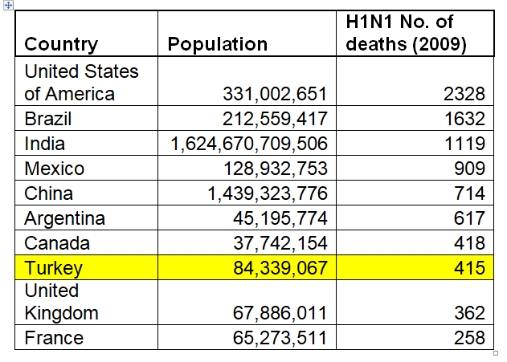
Again, only Turkey appears in the list but even its figures are lower than most. In fact, a number of Muslim countries appeared in the list with lowest deaths. It may be noted that WHO stopped producing detailed worldwide figures for Swine Flu after this.
In the 2009 flu pandemic, 11–21% of the then global population (of about 6.8 billion), equivalent to around 700 million to 1.4 billion people, are estimated to have contracted the illness. There were more than 18000 confirmed fatalities. However, in a 2012 study, the CDC estimated more than 284,000 possible fatalities worldwide, with numbers ranging from 150,000 to 575,000.⁴

A very interesting write-up, titled “The pigs' revenge” by Felicity Lawrence showed how the meat markets play an overpowering role in deciding the things. Here are few excerpts:
“The Fred Goodwin of the epidemic was easy to identify in their eyes. Just five miles from the town of La Gloria, which appears to be the epicentre of the flu outbreak, is a giant industrial pig complex jointly owned by the world's largest pig processor, Smithfield Foods….it is the very nature of today's globalised meat industry that is at the heart of this emerging swine flu pandemic. The factory unit near La Gloria fattens nearly a million pigs a year. Globally Smithfield slaughtered 26 million pigs in 2006, generating sales of $11.4bn (£7.6bn) and profits of $421m. It already controls over a quarter of the total US processed pork market and it has expanded by acquisition in Europe. Like the banking sector, the global food system has seen the emergence of unprecedentedly large players that are dominant at every stage of production from pig breeding to bacon slicing.
“At CDC the head of virology had completed the genetic fingerprinting of the swine flu and was able to say that it has arisen from a strain first identified on industrial pig units in North Carolina in the late 1990s. It is no coincidence that this threat to global human health should have emerged from that particular state, as Michael Greger, director of public health at the US Humane Society and leading author on the history of bird and animal flu explains: "North Carolina has the densest pig population in North America and boasts more than twice as many corporate swine mega-factories as any other state. With massive concentrations of farm animals within which to mutate, these new swine flu viruses in North America seem to be on an evolutionary fast track, jumping and reassorting between species at an unprecedented rate….
“Factory animal farming has developed as a giant ecological credit bubble. It has delivered enormous growth in global meat production over the last three decades. Consumers have happily bought its cheap products just as they gobbled up the freely-offered loans of the financial boom without asking too closely how such consumption could be sustained or what the eventual consequences might be. Swine flu should make us question that complacency.
“Large-scale producers pride themselves on their economic efficiency, but if the true costs of such polluting and disease-harbouring methods were internalised rather than externalised as environmental debts, they would be anything but good value. The cost of the flu pandemic will be unquantifiably large, but it is not the industry that will pay. Instead, the damage will affect the poorest disproportionately. It is ordinary Mexicans who are most affected now, just as the sub-prime mortgage crisis has made those at the bottom of the ladder homeless.
“Urged to spend our way out of ecological recession, we are exhorted to keep eating pork products. Keen to protect the economic interests of its meat industry, the US government took to calling this swine flu "H1N1 flu" a couple of days ago, in order not to put people off their chops. The World Health Organisation, which depends on the US for a large part of its budget and has been bullied by it before, has now followed suit, rebranding the flu influenza A (H1N1). But simply saying "as you were" is no more an adequate response to the cause of this current crisis than it is to the banking collapse.”⁵

HIV/AIDS
HIV/AIDS is another big Pandemic, which started in the 1980s and still continues to devastate in a big way. It has already killed more than 40 million people worldwide and still about 40 million are affected with it. It was much in the news till the first decade of this century with big AIDS control programmes stressing Safe Sex; but after the availability of anti-HIV antiviral drugs, these programmes have taken a backseat despite the fact that it is still killing more than six hundred thousand every year. This has devastated mainly those countries where promiscuity, prostitution, homosexuality and drugs are common, 650,000 people died of AIDS in 2021, a 52% decrease from 1.4 million in 2010 and a 68% decrease from the peak of 2.0 million in 2004⁶. But it is still a very big number. HIV remains a leading cause of death worldwide and the leading cause of death globally among women of reproductive age.

Sub-Saharan Africa, home to two-thirds of all people living with HIV globally, is the hardest hit region in the world, followed by Asia and the Pacific. Latin America as well as Eastern Europe and Central Asia are also heavily affected. Rates of HIV infection in the Middle East and North Africa (MENA) are among the lowest in the world. Even in the US, as of 2018, about 700,000 people have died of HIV/AIDS since the beginning of the HIV epidemic, and nearly 13,000 people with AIDS each year.⁷ According to another report; an estimated 1,189,700 people in the United States had HIV at the end of 2019. ⁸

Muslim countries have been relatively much less hit, especially in the period when HIV caused maximum devastation. The reasons in their being less hit include (a) stronger family system, (b) lesser involvement in promiscuity of all kinds including homosexuality; (c) lesser addiction to drugs and (d) circumcision of almost every male. If still, any Muslims have contacted HIV, it shows that they did not follow the Islamic principles the way they must be followed.

If the prevalence and death rate due to HIV/AIDS has been declining in last 15 years, the reasons include (a) rising popularity of circumcision (b) better use of condoms, which if associated with circumcision become highly protective: (c) availability of antiviral therapy, which is at least increasing the life expectancy.

HPV/Cancer Cervix
In last thirty years, more than 10 million women have died of Cervical Cancer. Cervical Cancer has direct relation with Human Papilloma Virus, which is transmitted through immoral and unhealthy sexual practices like promiscuity and prostitution. In males, normally it is not a deadly infection; but it causes Cervical Cancer in females. It is highly uncommon in women having relations with circumcised men.
Cervical Cancer or Cancer of the Cervix Uteri is the fourth most commonly occurring cancer in women and the seventh most common cancer overall. According to reports, there were more than 604,000 new cases of cervical cancer and 342,000 deaths in 2020.⁹
Every year in India, on an average, 122,844 women are diagnosed with cervical cancer and 67,477 die from the disease.¹⁰

The American Cancer Society's estimates for cervical cancer in the United States for 2022 are: about 14,100 new cases of invasive cervical cancer will be diagnosed; about 4,280 women will die from cervical cancer.¹¹

About 130,000 new cases occur annually in China, accounting for 28% of the total number of new cases for cervical cancer worldwide. The estimates of cervical cancer deaths were about 33,800.¹²

In Russia, every year 15308 women are diagnosed with cervical cancer and 7550 die from the disease.¹³

An estimated 1,450 Canadian women will be diagnosed with cervical cancer in 2022 and estimated 380 will die.¹⁴
In South Africa, every year 10702 women are diagnosed with cervical cancer and 5870 die from the disease.¹⁵

In Turkey, every year 2532 women are diagnosed with cervical cancer and about 1245 die.¹⁶

These figures show that in these areas more than 355000 women are diagnosed every year with Cervical Cancer and around 150000 die, which are more than half of the total worldwide figures. But when we try to find the top countries with the problem, the following list is there, which surprisingly uses a different yardstick to make the list.
The following table shows ten countries with the highest rates of cervical cancer and the highest number of deaths from cervical cancer in 2020”.
(Note: ASR = age-standardised rates. These are a summary measure of the rate of disease that a population would have if it had a standard age structure.)

Cervical cancer rates ¹⁷
Rank | Country | Number | ASR/100,000
 | World | 604,127 | 13.3
1 | Eswatini | 341 | 84.5
2 | Malawi | 4,145 | 67.9
3 | Zambia | 3,161 | 65.5
4 | Tanzania | 10,241 | 62.5
5 | Zimbabwe | 3,043 | 61.7
6 | Lesotho | 541 | 56.8
7 | Uganda | 6,959 | 56.2
8 | Comoros | 167 | 56.0
9 | Mozambique | 5,325 | 50.2
10 | Guinea | 2,068 | 50.1

Now interestingly the total number of cases in this list is less than 40000, which is not even 10 pc of the total cases.
The following table shows global cervical cancer mortality in 2020. Eswatini had the highest rate of cervical cancer mortality in 2020, followed by Malawi.
Rank Country Number ASR/100,000
World 341,831 7.3
1 Eswatini 214 55.7
2 Malawi 2,905 51.5
3 Zambia 1,904 43.4
4 Zimbabwe 1,976 43.0
5 Tanzania 6,525 42.7
6 Uganda 4,607 41.4
7 Comoros 109 39.8
8 Mozambique 3,850 38.7
9 Lesotho 362 38.1
10 Burundi 1126 38.5

Again this list has the number of dead less than 20000, which again is much less than 10 pc of the total number of deaths. We cannot understand the logic behind highlighting the case of these countries. It may be that these countries have high prevalence in a certain category; but excluding the countries which have more than half of the cases is not understandable. Again, this is in keeping with the attempts to hide the real position of a certain problem. This will hardly help in planning the strategy for the control of the disease at the global level though it can be of help for these few countries.

Covid-19
The following tables show the position of different countries in September 2022, and the trend of the countries has almost remained the same since then.

List of countries with total number of cases and deaths
(As available on the WHO website)

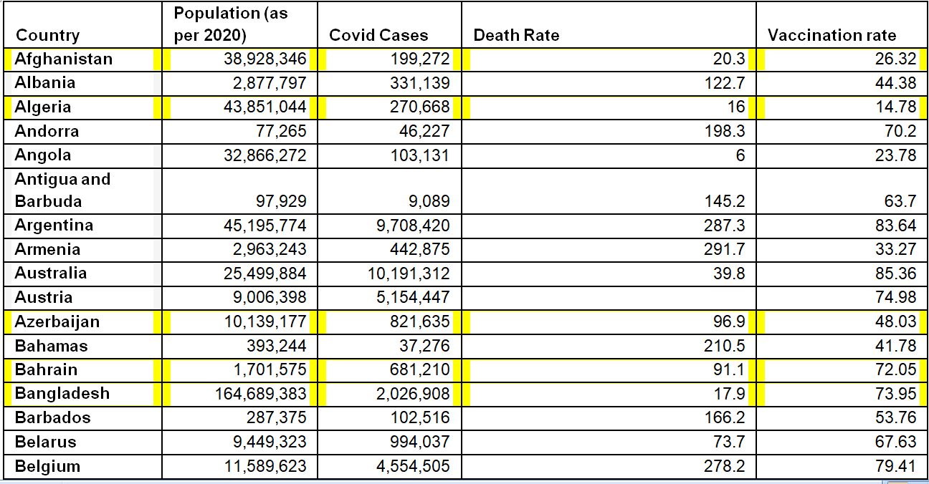

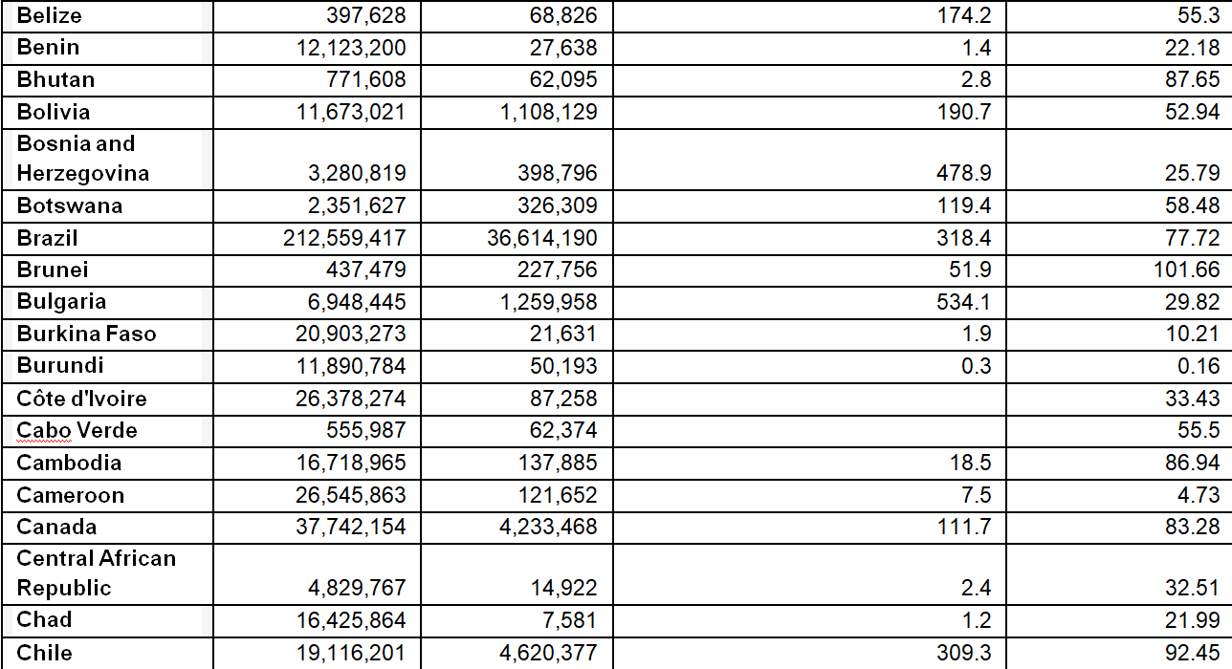
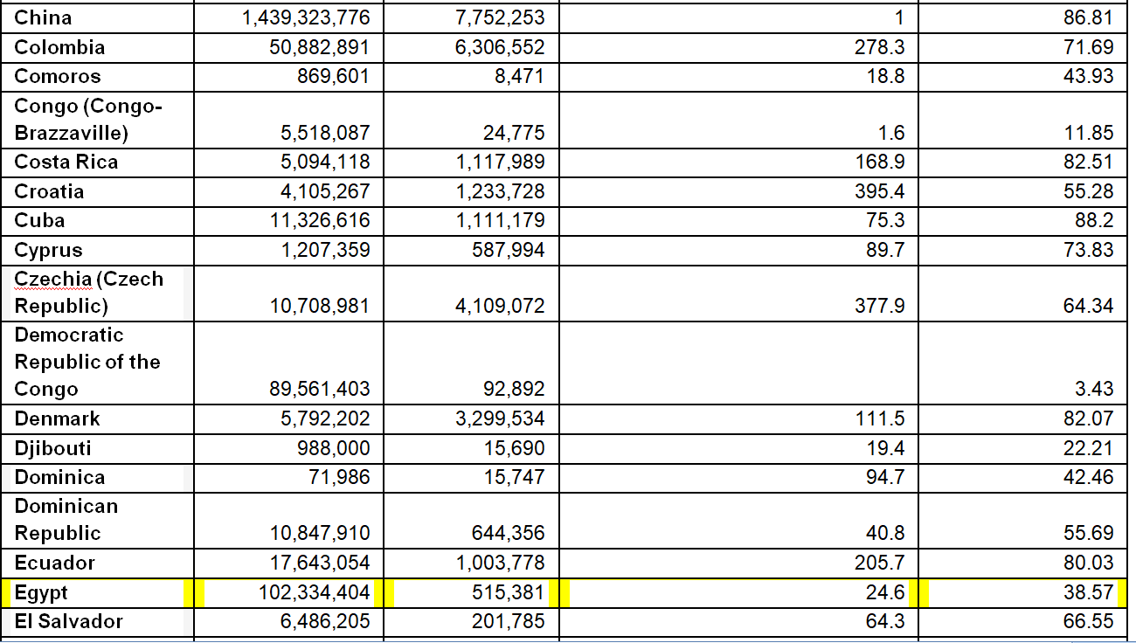
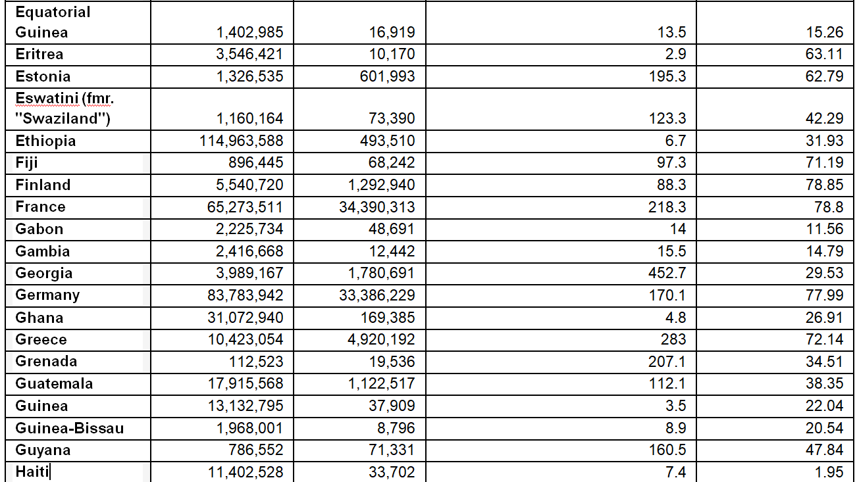
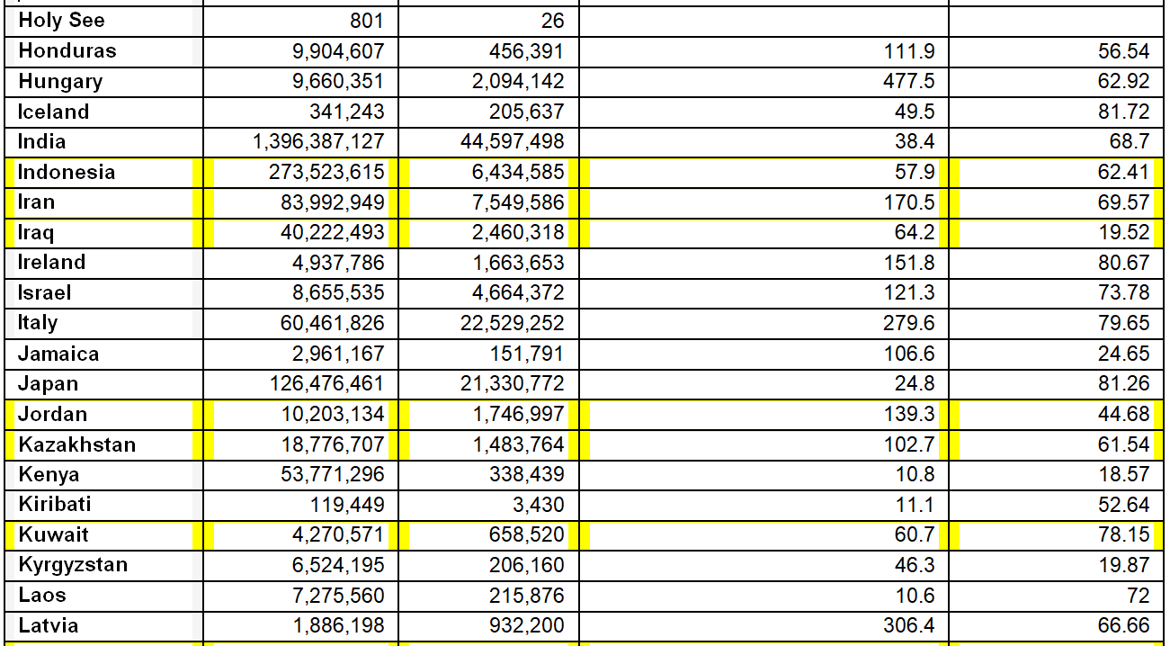
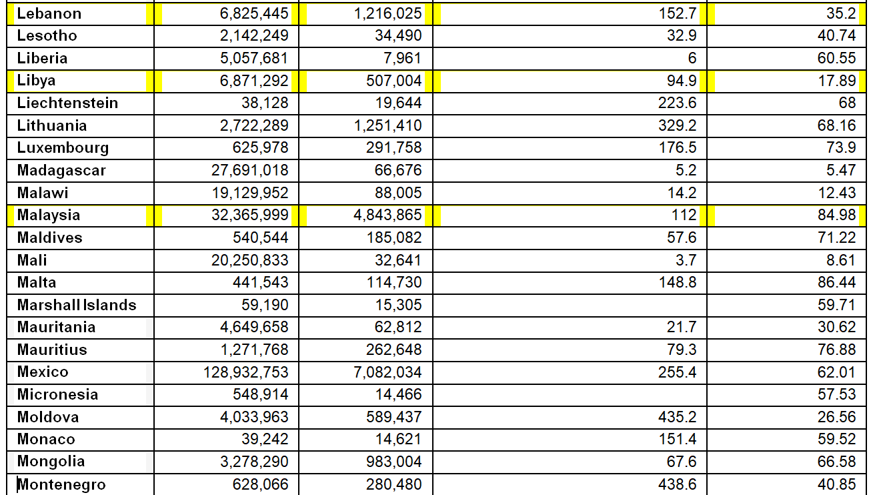
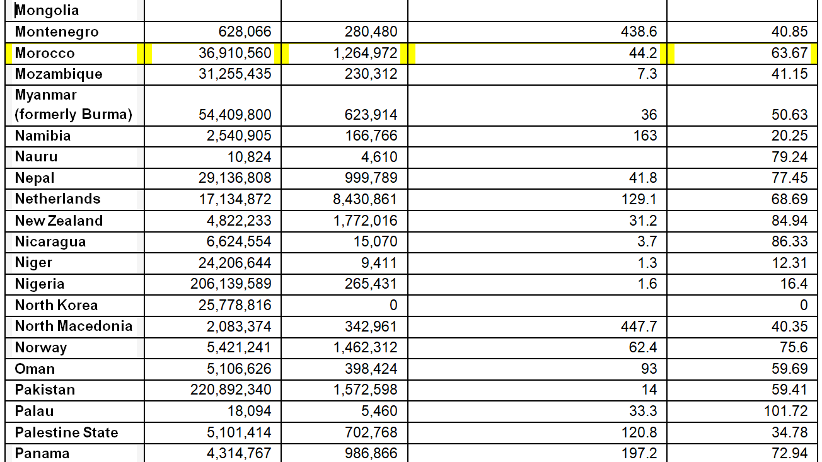
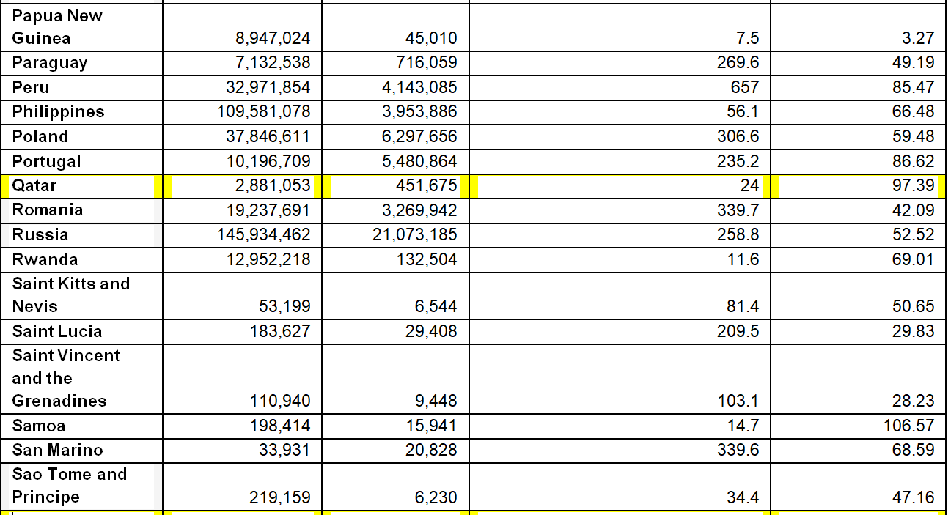
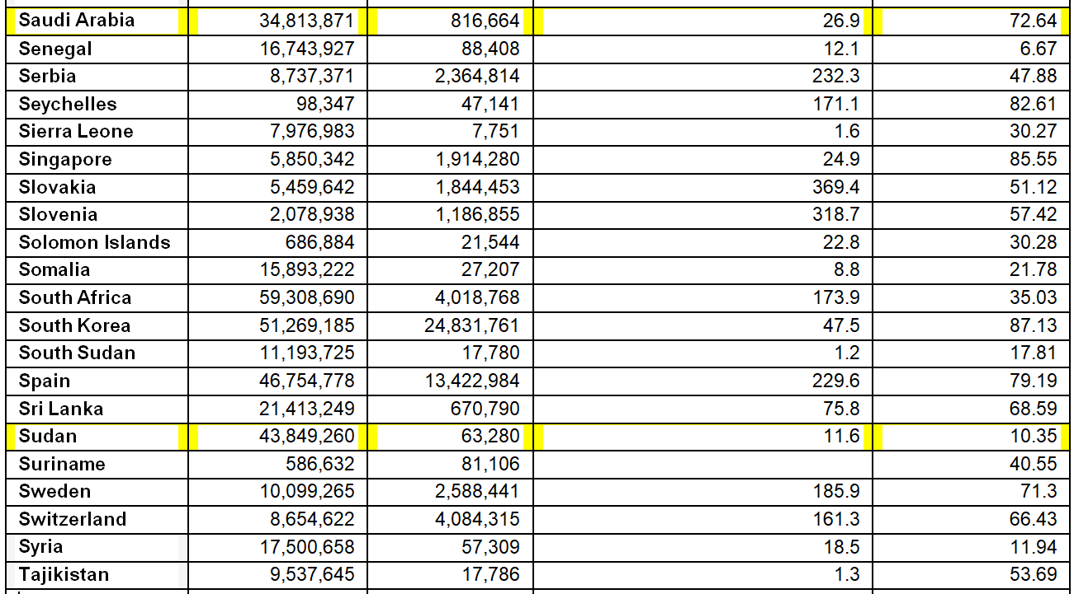
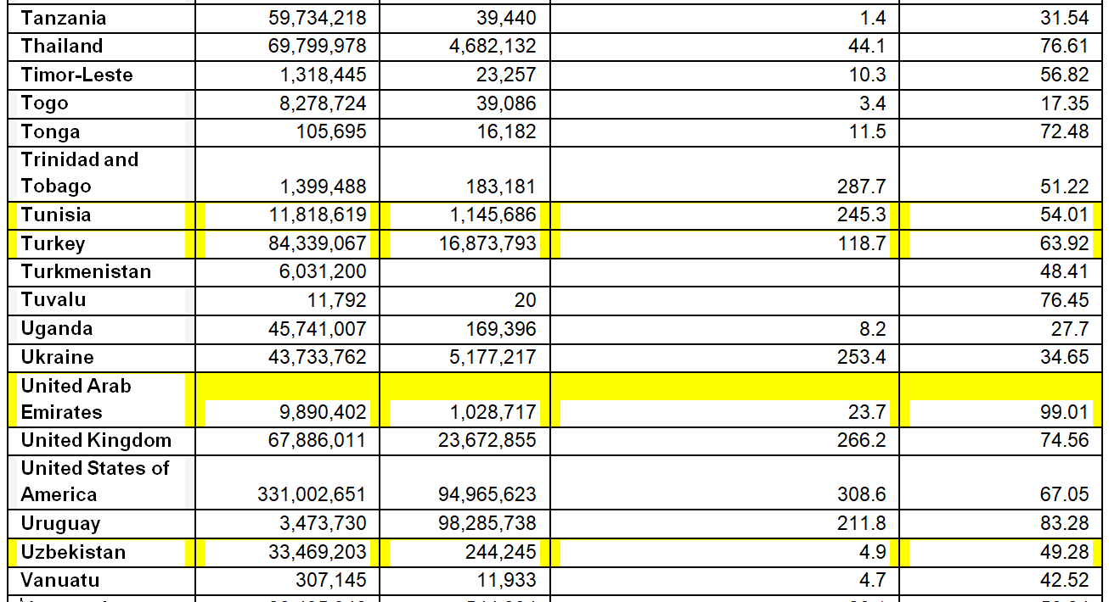
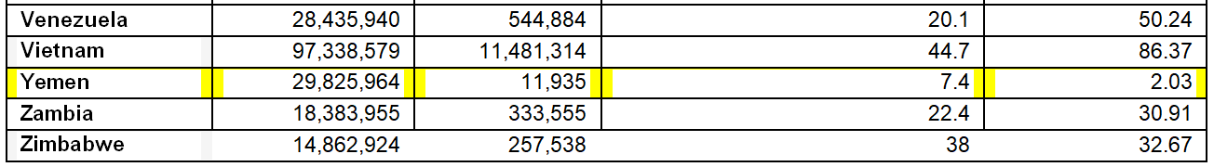

Top 5 Countries with the most Covid cases

Country | Cases
United States of America | 94,965,623
India | 44,597,498
Brazil | 36,614,190
Germany | 36,386,229
France | 34,390,313

Top 5 countries with most death rates (Deaths per ten thousand populations)
Country | Death Rates
Bulgaria | 534.10
Bosnia | 478
Hungary | 477.50
Georgia | 452.70
North Macadonia | 447.70

Top 5 Countries with the most vaccination Rates (per ten thousand)

Country | Vaccination Rates per ten thousand
United Arab Emirates | 99.01
Qatar | 97.39
South Korea | 87.13
Singapore | 85.55
Seychelles | 82.61

In the case of Covid, it is clear that the countries which have highly advanced healthcare system were almost all highly affected, both in the terms of the number of cases and total number of deaths. Why? It is evidently because of the kind of life style they have promoted in their countries, a lifestyle which is not health-protective. While in some other diseases that are the result of lifestyle, they try to control the problems with partial success through artificial preventive measures like vaccines and condoms, the Covid appeared all of a sudden, and the markets in these countries resisted any measures that would hit them. So, despite some Social Distancing measures like Face Masks and Sanitation, the night life and drinking continued even during Lockdown periods, and these became some of the major reasons of high positivity and high death rates.

According to a report, “Why Bars Continue to Be High-Risk Environments for COVID-19”, Alcohol directly impairs people’s ability and willingness to adhere to COVID-19 safety guidelines. The report mentions the following points:
“Despite the efforts of bar operators and guidance from the government, potentially significant risks of transmission of the coronavirus persists in bars, especially when customers are intoxicated…. Experts say alcohol seems to be one of the major factors fuelling this risk because it lowers inhibitions, making people less willing to comply with safety protocols.”
The Report adds:
“Debates over the safety of dining out at and patronizing bars and restaurants have been at the centre of these discussions.
“It’s been a hot button issue, prompting caution from health experts while drawing the ire and concern of business owners who have been hit hard by the health crisis and offered little to no financial support to adjust to the changes the pandemic has brought about…
“People under the influence of alcohol are less able to judge distances — their hearing is affected, so they speak more loudly and need to lean in to hear others….
“Dr. Jennifer Lighter, an epidemiologist at NYU Langone Health, told Healthline that bars are a risk given that they involve people walking around to talk to strangers in close proximity, often shouting over loud music.
“Intoxicated people talk closer and lose a sense of personal space. Those are all factors, which of course increase risk when we’re talking about indoor bar spaces,” said Lighter, who was not affiliated with this research.
“Dr. Joseph Khabbaza, pulmonary and critical care physician at the Cleveland Clinic, echoed those thoughts, saying alcohol — just like any drug — alters one’s ability to make judgments…… Similarly, if you are attempting to protect yourself and others from a communicable respiratory disease in a public space, it will be harder to do so responsibly while heavily intoxicated.
“It’s tougher to enforce guidelines at a bar, especially when there are TVs on and people are watching sporting events, for instance, which generate more emotional dialogue and cheering — anything that causes louder exchanges like that means the potential for more droplets to be released,” Khabbaza, who was also not affiliated with this research, told Healthline.
“She said that while an indoor bar is one of the “riskiest venues,” a restaurant, where people are sitting exclusively with their group or pod, away from others, with dividers between seats and tables, poses fewer risks.
“Outdoors is significantly safer. It’s easier to distance folks outdoors, but there is still going to be some risk,” Khabbaza added. “If you have people outdoors congregating around an outdoor TV sporting event maskless, well that is going to have some risk — it will be lower than if it was indoors, but still a risk.”¹⁸
Another report discusses about the effects of Cocaine and other drugs. Here are some excerpts:
“With respect to mask-wearing at events, those who used cocaine were more likely to never wear a mask (44.2% vs. 28.4%, p = 0.047), and there was a significant difference detected regarding level of attendance (p = 0.001), with 53.9% of those attending >10 parties never wearing a mask (compared to 21.1% of those who wore a mask sometimes/always)”
About the effects of the failure of the governmental restrictions in New York City, the report says,
“..a large component of NYC’s widespread shutdown measures targeted the nightlife scene, likely due to a fear of superspreader events [4, 18, 19]. However, news outlets in NYC have covered many occurrences of illegal parties throughout the pandemic in spite of the Governor’s shutdown orders [20,21,22,23,24,25]. Indeed, it has long been known that this subpopulation is at greater risk of extensive drug use compared to the general population [26,27,28,29], but the added element of illegally attending dense parties during a pandemic—and potentially without adhering to mask recommendations—makes their risky behaviours an underscored concern….”
The report sums up as follows,
“A total of 43.9% attended private parties with more than 10 people, 27.3% attended nightclubs, and 20.5% attended other parties such as raves. Among those who attended any, 32.3% never wore a mask and 19.3% reported attending parties in which no one wore a mask. Past-year ecstasy use was associated with increased risk for attending private (aPR = 1.51, 95% CI: 1.00–2.28) or other parties (aPR = 2.75, 95% CI: 1.48–5.13), and use of 2C series drugs was associated with increased risk for attending nightclubs (aPR = 2.67, 95% CI: 1.24–5.77) or other parties (aPR = 2.50, 95% CI: 1.06–5.87). Attending >10 parties was associated with increased risk for never wearing a mask (aPR = 2.74, 95% CI: 1.11–6.75) and for no other attendees wearing masks (aPR = 4.22, 95% CI: 1.26–14.07). Illegal dance parties continued in NYC during the COVID-19 shutdown.”¹⁹
Relation to free sex life
The free sex life in most Western countries has largely contributed to not only the rise in Covid related morbidity and mortality but also to the cases of STDs because of the divergence of focus from STDs to Covid control.
Here are excerpts from reports that clearly point out to the link:
“Relationship between how COVID-19 further increases the rate of Syphilis in the USA. COVID-19 significantly precipitated the spread of various STIs by means of various social cofactors including lockdowns. Among those STIs, syphilis is worth mentioning, which is surging in the USA amid COVID-19 because of decreased in-person patient care due to social distancing and reduced syphilis screening…
“According to World Health Organization, seven million individuals got infected globally with syphilis in 2020, and unhygienic sexual practices amongst men who have sex with men (MSM) account for the highest incidence of infection [3]. A recent report estimated that more than 129 thousand cases of syphilis were reported in the United States as of 2019, with more than 1800 cases of congenital syphilis (see Fig. 1 and Fig. 2 ). An unexpected increase has been seen in 2020 and 2021, thus highlighting an alarming ongoing concern” ²⁰
It is quite clear that these diseases have hit Muslim countries much less than the other countries. Swine Flu, HIV, HPV related Cancer and Rabies – all these are relatively much less common in Muslim counties and societies. This is despite the fact that once an epidemic starts, it can affect even those who are not involved in the forbidden practices. Moreover, it is also a fact that Muslims too do not follow Islam as perfectly as they must. Countries like Turkey and Egypt have already had huge western influences; in recent time, even countries like UAE have allowed considerable liberty in terms of sex life and drinks. These countries are more and more likely to be affected of STDs and Alcohol/Drugs related issues in future if the trend continues. But irrespective of what Muslim societies exhibit, one thing is sure that the practices prohibited in Islam (related to sex, food and drinks) have had the biggest negative impact on world health situation in last few centuries. It is unfortunate that several Muslim societies have succumbed to the pressures of the global markets and have been toeing the Western line.
It is however to be seen that the Big Five countries are bad models for the humanity if health and social order are taken as the criteria.

Country | Population | Covid Cases | HIV rates
United States of America | 331,002,651 | 94,965,623 | 0.36
United Kingdom | 67,886,011 | 23,672,855 | 0.20
France | 65,273,511 | 34,390,313 | 0.278
China | 1,439,323,776 | 7,752,253 | 0.09
Germany | 83,783,942 | 33,386,229 | 0.105
The table denotes the Big 5 countries of the world where in the Covid cases and HIV rates have been mentioned.
Despite following the Western trends however, sex related diseases have been far less common in Muslim countries because of relatively much lesser involvement in what are considered prohibited practices in Islam and almost one hundred percent circumcision. For the same reason, Covid has been far less destructive in most Muslim countries than others. See the following table, which shows the position of Covid and HIV cases in some Arab countries.
Country | Population | Covid Cases | HIV rates per ten thousand
United Arab Emirates | 9,890,402 | 1,028,717 | -
Qatar | 2,881,053 | 451,675 | 0.20
Kuwait | 4,270,571 | 658,520 | -
Jordan | 10,203,134 | 1,746,997 | 0.20
Saudi Arabia | 34,813,871 | 816,664 | -

Obviously, relative to most countries, these are on the lower side.
Indian Subcontinent
Indian Subcontinent has three main countries, India, Pakistan and Bangladesh. Culturally and socioeconomically, the three have similar records. But while India has predominant Hindu population with Muslims being the second largest majority, Pakistan and Bangladesh are Muslim majority countries with much lower Hindu population. But it is clear from the figures related to Covid that Pakistan and Bangladesh were much lesser hit than India. Here are the figures related to Covid:
India
Covid Cases: 44,645,768 as of 2022
Covid death: 528,981 as of 2022

Pakistan
Covid cases: 1,573,725 as of 2022
Covid deaths: 30,624 as of 2022

Bangladesh
Covid Cases: 2,035,334 as of 2022
Covid death: 29,424 as of 2022

While the population of India is about 6-7 times of the population of both Pakistan and Bangladesh, the difference in the number of cases is around 15 to 20 times. This is despite the fact that, in terms of healthcare and over-all development, India is surely more advanced than both. The possible reason for this difference may again be related to lifestyle with liquor and night life being more aggressive in India than in the other two. Liquor and Prostitution are officially banned in Pakistan though in reality both exist but surely in lesser percentage than in India.

7.
Commerce of the Causes of Problems and the Commerce of Solutions

As has been the central theme of this work, the current international world order is a system governed, directly or indirectly, by the forces of economics, and it chiefly caters to their requirements and demands. Health is the most notable victim. The interesting part of the whole state of affairs is that the forces of economics thrive first on commercializing the causes of the problems (Aetiologies) and then on commercializing their solutions (Management). They are not interested in prevention of the diseases altogether through natural methods and prefer to let the problems bloom; and then their solutions are presented. The causes of the problems bring huge economic dividends; and the solutions bring no less.

Let us first have a brief look into the economics of the causes. These are some of the facts regarding various industries related to the substances and practices, which lead to serious life-threatening problems:
- The global online gambling market size was valued at USD 53.7 billion in 2019, and is expected to grow at a compound annual growth rate (CAGR) of 11.5% from 2020 to 2027.¹
- Revenue in the Alcoholic Drinks market amounts to US$1,484.00bn in 2022. The market is expected to grow annually by 10.01% (CAGR 2022-2025). (CAGR 2020-2023).²
- The global market for Opioid drugs should reach $29.8 billion by 2023 from $26.4 billion in 2018 at a compound annual growth rate (CAGR) of 2.5% for the period of 2018-2023.³
- There are about 42 million prostitutes living all over the world.⁴ Estimates place the annual revenue generated by prostitution worldwide to be over $100 billion⁵. The majority of prostitutes is female and has male clients.
- The global condom industry has been forecast to hit a market value of US$ 5.4 billion by 2018.⁶
- LGBT Capital estimates the Global aggregated spending power of this consumer base (the LGBT-GDP) to be around US$ 3.9 trillion per annum (measured as Nominal GDP) - from a 15+ LGBT population of about 371 million individuals globally.⁷
- According to estimates, at present, there are around one billion pigs in the world. As a result of these factors, the hog production and pork market are projected to reach a market value of ~US$ 464 billion by the end of 2027.⁸
- Dogs are also a big market and ARV vaccine too is a big market. The global pet care market is expected to reach USD 202.6 billion by 2025, according to a new report by Grand View Research, Inc. Rise in the adoption of pets and growing demand for premium care products are few factors expected to drive market growth.⁹
I could not find the statistics related to the wild meat market; but this too is a multibillion-dollar industry.

The Global Burden of Diseases has large portion of the diseases due to these practices. And then there is Solution Market for the diseases caused by these practices. The global market for healthcare services reached a value of nearly $6707.3 billion in 2018, having grown at a compound annual growth rate (CAGR) of 7.6% since 2014, and was expected to grow at a CAGR of 9.3% to nearly $9,581.0 billion by the end of 2022.¹⁰

COVID-19 pandemic has given a chance to the world to realize that:
  - Economics needs to be Health-friendly, and if Economics continues to develop at the cost of health, it will time and again hit back at the economics.
  - Most of the pandemics in recent history have had a direct relation with the commercialization of the practices and substances, which have highly dangerous impact on health.
  - The current model of international economics, which has accentuated Economic Inequality to dangerous proportions, will fail whenever big disasters, in the form of pandemics, or other natural disasters, will strike the world.
  - The whole Economic Model needs to be revised in a way that it ceases to pose dangers to human life through diseases and crimes of various kinds;
  - Economic Growth based on the wasteful expenditure by the people first in spending on dangerous practices and substances and then on the treatment may appear to point towards the success of economics; but in reality it does not. The humanity needs to develop a model where the people can lead a happy, prosperous and peaceful life within even small incomes; because they have not to waste their money on items that ultimately lead to physical problems and bigger financial requirements. Economic prosperity should be reflected not only in their ability to expend but also their ability to save, with their savings later going towards their own empowerment through healthy investments.
  - It has also reminded Islamic scholars that they need to focus more on Applied Islam, and the current Model of “Islamic Economics” developed by certain groups which have interest in banking and financing (in Muslim community) is not good enough representation of Islam’s holistic system of health and peace, and is not grand enough to challenge the international economic order. They also need to develop and present to the world an Islamic Paradigm of Health.
Commerce of the problems
The following table shows the global expenditures incurred on entertainment, which give an idea of the extent of the commercialization of vices:
Global Entertainment Expenditures¹¹
Entertainment Category | (in bil. US$)
Alcohol | 1,163
Entertainment Drugs | 546
Sex | 400
Restaurants | 183
Movies | 180
Gambling | 110
Sports | 63
Computer Games | 54
Live performances | 35
Tourism | 25
Music | 7
Total | 2,862

The Table shows that more than 2000 billion US dollars are spent on sex, alcohol, drugs and gambling. This money is being spent to purchase items that sooner or later are likely to lead to severe medical and social problems including death. Social problems include serious family disturbances, abortions, single parenthood, and separation with one or both parents, all of which in turn can lead to severe psychiatric problems with additional financial cost.
Global Gambling Revenues
NATION | US$ Bil.
United States | 94.9
Japan | 35.4
Italy | 16.0
UK | 15.1
China, Hong Kong, Macau | 14.8
China | 5.13
Canada | 14.7
Australia | 13.2
France | 11.8
Spain | 11.7
Germany | 11.2
Macau | 7.2
China | 5.1
South Korea | 4.8
South Africa | 4.4
Russia | 4.2
Brazil | 4.1
Argentina | 3.4
Greece | 3.1
The Netherlands | 2.8
Switzerland | 2.7
Singapore | 2.6
Sweden | 2.5
Hong Kong | 2.5
Antigua and Barbuda | 2.0
Portugal | 1.9
Finland | 1.6
Total Global | 305.7

The global gambling industry is dominated by developed nations, with the US, the EU and Japan combined accounting for close to 70% of the overall market¹².
The online sports betting market has grown from about 24 billion U.S. dollars in 2004 to approximately 74 billion U.S. dollars in 2012¹³.

"World Online Gambling Markets" says the global online gambling market generated $834.5 million in 1998 - an increase of more than 100 percent over 1997. The market has considerably swelled since then. Research firm Datamonitor forecasts that revenues from gambling will soar to $20.8 billion by 2005¹⁴.

Sex Industry
Global sex industry is more than 400 billion dollar industry. The figures are several years old and may have considerably increased by now. Here is some more information:
Human Trafficking business¹⁵
- China$73 Billion
- Spain$26.5 Billion
- Japan$24 Billion
- Germany$18 Billion (Legal Industry)
- United States$14.6 Billion
- South Korea$12 Billion
- India$8.4 Billion
- Thailand$6.4 Billion
- Philippines$6 Billion
- Turkey$4 Billion
- Switzerland$3.5 Billion
- Indonesia$2.25 Billion
- Taiwan$1.84 Billion
- Ukraine$1.5 Billion
- Bulgaria$1.3 Billion
- United Kingdom$1 Billion
- Netherlands$800 Million (Legal Industry)
- Italy$600 Million
- Cambodia$511 Million
- Israel$500 Million
- Ireland$326 Million
- Czech Republic$200 Million
- Jamaica$58 Million
- Australia$27 Million

According to reports, the number of Prostitutes in the World is 13,828,700 with the following breakup.¹⁶
- China 5 Million
- India 3 Million
- United States1 Million
- Philippines 800,000
- Mexico 500,000
- Germany 400,000
- Brazil 250,000 children
- Thailand 250,000
- Bangladesh 200,000
- South Korea147,000
- Turkey 118,000
- Taiwan 100,000
- Cambodia 70,000
- Ukraine 67,500
- United Kingdom58,000
- Kenya50,000 children
- Vietnam 33,000
- South Africa 30,000 children
- United Arab Emirates 30,000
- France20,000
- Switzerland 20,000
- Poland 19,000
- Mongolia 19,000
- Israel 17,500
- Costa Rica15,000
- Netherlands 7,000
- New Zealand 3,5000
- Denmark 3,200
- Ireland 1,000

Here are some more facts based on various reports:
- Estimates place he annual revenue generated from the global prostitution industry to be over $100 billion.¹⁷
- The global condom industry has been forecast to hit a market value of US$5.4 billion by 2018.¹⁸

Homosexuality too is a big industry and is growing fast. In fact it is the fastest growing among all the sex industries and has also become a big player in tourism industry. A few years old report entitled, “Gay-Friendly Vancouver as a Billion Dollar Industry” said:
“At present, Vancouver is hyping the 2010 Olympics above all. The pride of a city has turned into its most lucrative business. Now the tourism industry has founded a new market, which has always existed but its potential as a distinct market was not realized: the "gay market," According to Canada.com, gay tourism in Vancouver has been a lucrative and loyal sector within recent years. Gay tourism in the U.S. alone is estimated to be $55 billion annually (Constanineau, 2007). A survey conducted by San Francisco-based Community Marketing Inc, ranked Vancouver as the fourth most popular gay destination outside of the U.S., ranking Montreal and Toronto fifth and sixth respectively, which shows how well Canada’s gay tourism industry is doing overall (Constanineau, 2007). Constanineau also says that tourism Vancouver uses media to draw in a lot of its gay market from U.S. locations such as New York, San Francisco, and Los Angeles. One of the possible reasons suggested for Vancouver’s gay tourism industry is due to the fact that BC legalized same-sex marriage in July of 2003. …Boyd (2008) mentions that there was a Canadian boom in gay tourism right after same-sex marriage was legalized. She suggests this is because it produces homo-normativity: “a set of ideologies and behaviours that asserts citizenship rights for gays and lesbians via neoliberal politics and conspicuous consumption” (Boyd, 2008, p. 224). Boyd (2008) also mentions how weddings are huge businesses; a $70 billion industry in 2005 in the U.S. alone, with an average of $30,000 per wedding. Even Forbes in 2004, estimated that same-sex marriages in the U.S. could have drawn in $16 billion (Boyd, 2008). In order to “corporate gayness” sites have to promote their destination as “gay friendly” since “social disapproval of homosexuality many gay men are forced to find gay space” (Puar, 2002, p. 103). In fact, organized gay tours began in the 1950s by the “grandfather of gay travel,” [[Haans Ebensten]] (Puar, 2002), long before the mainstream travel industry caught wind.¹⁹
Another article describes why legalising gay marriages is lucrative for the governments:
“James Alm, M.V. Lee Badgett, and Leslie Whittington estimate that legalizing gay marriage would lead to an annual increase in federal government income taxes of between $0.3 billion and $1.3 billion. Remember those Medicare and Medicaid woes the DOMA proponents were concerned with? These added revenues could be used to help offset the costs of other economic advantages to marriage.
“Besides, weddings are great for the economy. The 2000 U.S. Census Bureau reported 601,209 unmarried same-sex partner households in the United States living in 99.3% of all counties in the nation. The Urban Institute claims that the census data is low and suggests that gays and lesbians make up about 5% (10,456,405) of the total U.S. population over the age of 18. …We can estimate that some portion of the same-sex partners already living together (the 2000 U.S. Census Data figures) along with some portion of the total gay and lesbian population would wish to marry if same-sex marriage became legal. For the sake of convenience we'll say 500,000. According to Bride's Magazine, the average wedding costs $19,000. Two hundred-fifty thousand more marriages at the average wedding rate would result in wedding costs of $4.75 billion! Mind you, this doesn't include the amount spent on wedding gifts. As a bonus, the first states to allow gay marriage will likely experience an influx of tourism and tourist-related economic activity. For the short time that San Francisco mayor, Gavin Newsom, issued wedding licenses to same-sex couples, more than 3,000 gay and lesbian couples from more than twenty states and Europe flocked to the city to be married.
“Of course, weddings are just the tip of the iceberg. For some marriages there is even the coup de grâce: divorce. As the majority of divorcés will tell you-the most expensive part of getting into a marriage is getting out. While divorces can range anywhere from several hundred dollars to millions, divorce is a multi-billion dollar-a-year industry. Assuming that gay couples divorce at the same rate as heterosexual ones, I am surprised the legal battle is not fully endorsed by Divorce Lawyer Associations everywhere!
“A Media financial report says, “"In the six short months since Chicago was selected as host of Gay Games VII, we've made dramatic progress toward our financial goals and achieved fundraising benchmarks months, or in some cases, years ahead of schedule," said Tracy Baim, CGI Board Co-Vice Chair and Chair of the Fundraising Committee. "Once broadcast rights are assigned, we will have raised more than US$3 million in cash and in-kind resources." CGI announced a million-dollar sponsorship deal with PlanetOut Inc. on 20 September 2004. …. In a recent edition of the "Advocate," a national publication for the gay and lesbian community, there were three pages of ads promoting Palm Springs' hotels and attractions that cater to homosexuals. Murrell Foster, executive director of tourism for Palm Springs, said it is the first time the city has been promoting itself to the gay market. Los Angeles County travel agents said they have become more active in pursuing the market largely because of the recession.” ²⁰
Alcohol

According to IMARC, the global alcoholic beverages market was valued at US$ 1,516.5 Billion in 2021.²¹ The EU represents almost 57% of the world alcoholic drinks market²².

How market forces influence the governmental policies is nicely presented in a report published in Lancet about how World Trade Organisation worked to downscale the threat posed by Alcohol. Here are a few excerpts from the report:
“Similarly, WTO members focused on a narrow set of conditions in which harms arise. This descaling of the problem occurred when they noted the “risks posed by alcohol consumption to those underage, pregnant, or driving” (Canada to Turkey, G/TBT/M/61), rather than the general population. It also occurred when discussions focused on harms arising from “driving under the influence of alcohol” (USA to South Korea, G/TBT/M/79), rather than in other contexts. WTO members further minimised the issue by emphasising beneficial effects. For example, a Mexican representative stated that scientific literature “stressed that moderate consumption of alcohol was also regarded as an important part of a healthy lifestyle” (Mexico to South Korea, G/TBT/M/70).
WTO members also promoted the idea that, instead of adopting the proposed measure, industry should be a partner in alcohol harm reduction and help government to identify alternatives (n=8 statements), which industry has often proposed in domestic settings. The USA, for example, stated that it “supported several public–private partnership initiatives related to combating the harmful use of alcohol” (USA to South Korea, G/TBT/M/87). Mexico also requested South Korea to hold “a video conference with the South Korean authorities responsible for the measure, in order to clarify the nature of the scientific and technical information considered in connection with its implementation and to examine industry's arguments concerning existing scientific literature” (Mexico to South Korea, G/TBT/M/70)….
Our analysis found that discussions on ten alcohol health warning labelling policies at TBT Committee meetings of the WTO, during 2010–19, featured arguments that are regularly advanced by industry in domestic settings to prevent potentially effective alcohol policy implementation. However, WTO members stated that their claims represented industry in just seven (3·3%) of 212 statements, whereas we found that 117 (55·2%) statements were similar to the policy positions and discursive strategies used by the alcohol industry in domestic policy forums.
Specifically, we identified instances in which WTO members claimed that the policies were unnecessary, costly for manufacturers and the economy, and an administrative burden for industry, and that alternative, less costly and less trade-restrictive policies should be adopted. Members questioned the evidence used to develop the policies, promoted the ideal of evidence-based policy, and claimed that the measures were scientifically inaccurate. These claims were raised alongside statements that deflected attention, descaled or minimised the problem, and reframed the issue in ways that downplayed the need for policy intervention. For example, alcohol-related harms were described as arising from excessive or problem drinking, or as only applying to a specific set of conditions (such as drink driving or during pregnancy), whereas moderate or responsible drinking was deemed unharmful and even healthy. Members subsequently advanced alternative, non-regulatory, and targeted approaches for alcohol harm reduction, such as information and awareness campaigns (as opposed to the population-wide labelling approach being proposed), and promoted industry as a partner in the development of these policies. These arguments are all similar to those repeatedly used by industry to counter potentially effective policies and disseminate doubt about the harms of alcohol consumption and the efficacy of proposed interventions in domestic settings.
…. First, the influence of industry can be direct when the member receives a submission from, or engages in discussion with, domestic industry about its position and the member repeats the industry position in the Committee, as identified in seven statements. Second, influence might be indirect, with no discussions between the WTO member and industry about the specific measure. However, the industry's arguments made in domestic policy settings on other occasions might feature because alcohol advertising, paid newspaper articles, paid research, and publicity on the health benefits of alcohol might influence the government's stance on the issue. Third, WTO members might question alcohol-labelling policies as a result of a proliberalisation ideology and a desire to promote national economic interests, which often coincide with alcohol industry interests……
Furthermore, the TBT Agreement acknowledges the protection of public health as a legitimate policy objective, yet the focus of discussions at the Committee meetings is on raising concerns about proposed measures and their potential inconsistencies with the Agreement. This environment might encourage the prioritisation of trade over health interests.
…As with other health harming industries, our findings raise concerns about the influence (direct or indirect) that vested commercial interests can exert at the WTO and suggest this influence needs to be addressed to accelerate global alcohol policy implementation. …
“Our findings have important implications for policy makers seeking to address the growing global burden of illness and mortality associated with alcohol consumption, and related targets, within the WHO global alcohol strategy and Sustainable Development Goals. .. The UN and WHO also have an important role in fostering dialogue between trade and health sectors.
Public health researchers and trade policy analysts should continue to ensure that new trade liberalisation rules do not create negative health, social, or environmental externalities…”²³

Commerce of the Solutions
Problems are being purposely created or sustained and are used to make huge money. There is no interest whatsoever in not allowing the problems to appear because this kind of approach would obviously not create dollars. First dollars are earned through practices that create problems. Then every problem brings huge money through solutions: Medicines, hospitals, legal issues, insurances of various kinds and many others.

According to WHO, the total global expenditure for health by the countries is US$ 6.5 trillion. Total global expenditure for health per person per year is US$ 948²⁴. Obviously a big chunk of this expenditure is on diseases that are avoidable through following a system of comprehensive hygiene including general hygiene, avoidance of substances and practices that damage health, and establishment of a health-protective family and social, political and legal system. The OCED and WHO lists of total health expenditure per capita are given below:

List of countries by total health expenditure (PPP) per capita
Total health expenditure per capita in US dollars (PPP).²⁵
 | Country | 2012 | 2013 | 2014 | 2015
1 | Australia | 3808 | 4177 | 4207 | 4420
2 | Austria | 4646 | 4806 | 4896 | 5016
3 | Belgium | 4286 | 4485 | 4522 | 4611
4 | Canada | 4320 | 4503 | 4492 | 4608
5 | Chile | 1485 | 1558 | 1689 | 1728
6 | Czech Republic | 2028 | 2330 | 2386 | 2464
7 | Denmark | 4545 | 4708 | 4857 | 4943
8 | Estonia | 1503 | 1623 | 1725 | 1824
9 | Finland | 3759 | 3891 | 3870 | 3984
10 | France | 4063 | 4292 | 4367 | 4407
11 | Germany | 4695 | 4922 | 5119 | 5267
12 | Greece | 2324 | 2340 | 2220 | 2245
13 | Hungary | 1704 | 1756 | 1797 | 1845
14 | Iceland | 3506 | 3739 | 3897 | 4012
15 | Ireland | 4658 | 4980 | 5001 | 5131
16 | Israel | 2273 | 2473 | 2547 | 2533
17 | Japan | 4017 | 4152 | 4152 | 4150
18 | Korea | 2132 | 2225 | 2361 | 2488
19 | Italy | 3174 | 3142 | 3207 | 3272
20 | Latvia | 1149 | 1219 | 1295 | 1370
21 | Luxembourg | 6423 | 6629 | 6682 | 7765
22 | Mexico | 1006 | 1021 | 1035 | 1052
23 | Netherlands | 5044 | 5250 | 5277 | 5343
24 | New Zealand | 3199 | 3486 | 3537 | 3590
25 | Norway | 5738 | 5967 | 6081 | 6567
26 | Poland | 1464 | 1580 | 1625 | 1677
27 | Portugal | 2536 | 2539 | 2584 | 2631
28 | Slovak Republic | 2000 | 2073 | 1971 | 2064
29 | Slovenia | 2487 | 2549 | 2599 | 2644
30 | Spain | 2929 | 2952 | 3053 | 3153
31 | Sweden | 4860 | 5003 | 5065 | 5228
32 | Switzerland | 6289 | 6635 | 6787 | 6935
33 | Turkey | 911 | 969 | 990 | 1064
34 | United Kingdom | 3192 | 3881 | 3971 | 4003
35 | United States | 8423 | 8617 | 9024 | 9451

Health Expenditure per capita,2014 (OECD stat)

Pork market
It is expected to reach a value of $242.04 billion in 2022 and it will grow further to reach $258.39 billion in 2026 but at a slower CAGR rate, of only 1.6%.²⁶
Dogs
The global pet care market size is expected to reach USD 232.14 billion by 2030.²⁷
The solution to the problems related to dogs is also quite high in terms of expenditure. According to “Rabies vaccines: WHO position paper”, the annual expenditure for rabies in Africa and Asia has been estimated to be $584 million, and globally, $6 billion in direct costs and lost productivity; the cost of post exposure prophylaxis with rabies immune globulin and vaccine accounts for a significant proportion of this expenditure. ²⁸

8.
Islamic Philosophy of Holistic Health and Peace Economics
In order to understand the true nature, scope and extent of the Islamic philosophy of economics, we need to know what Qur’an intends and how the aims of Islamic philosophy are different from the current philosophy. These are some of my observations on the subject:
1. The current economic philosophy that rules the world revolves around economic fundamentalism, which dominates all the spheres of life. Its overriding influence can be seen in all the programmes at every level and in every field. Islamic economic philosophy is based on the supremacy of peace, which is a comprehensive state covering individuals, family and society; human peace, health, security and welfare are the guiding factors, and howsoever strong the economic reasons are, any activity that threatens health and comprehensive peace cannot be permitted.
2. In Islam, economics cannot be seen or developed separately from the grand objectives of the system. The economic system has not only to work within the framework of Fundamental Rights, Fundamental Duties and Fundamental Prohibitions; but has also to play a proactive role in achieving those objectives. In the current economic scenario, market forces rule and play the most decisive role in determining what is good or bad for society. Their interests are more often than not directly opposite to the interests of a healthy, secure and peaceful society.
3. Islam makes a clear distinction between prohibited, undesirable, desirable and highly desirable activities, depending upon their effects on health and social peace.
4. The aims and objectives of Islamic philosophy of economics are for the whole world, not just for the Muslim world. Its aims are:
(i) To ensure the overall peace in society at every level: individual, family, national and international;
(ii) To ensure that no individual or group of individuals indulges or is made to indulge in any activity that is dangerous to their own health or the health of others or for the general level of peace and security of society;
(iii) To ensure that all the activities are duly rewarded in accordance with their benefices for society or punished in accordance with their hazards.
(iv) To ensure that while individuals are given adequate freedom to engage in economic activities of their liking, society/system acts proactively to reverse any large scale disparities and prevent all forms of exploitation;
(v) To ensure that the disabled, the less privileged, the needy and the ones who sacrifice themselves for larger aims are duly protected, socially and economically;
(vi) To ensure that the diverse abilities of individuals are given societal and economic support.
The true nature of Islamic Economics can be captured in the following definition:
”Islamic Economics refers to the establishment of a world order where people, individuals or groups, are free to earn their livelihood through rightful use of the provisions of God and their abilities, natural or acquired, without the violations of the true goal of Comprehensive Peace that Qur’an envisages, that is within the boundaries of the three-dimensional system of Fundamental Rights, Fundamental Duties and Fundamental Prohibitions, and the establishment of a system that ensures comfortable living for each and every human being, including those who are in a disadvantageous position, temporarily or permanently, due to some reason.”
It needs to be emphasized that economics is not just about the currency, but is also about the work and services; it is not just about the goods and services produced by the big industry, but also about the services and goods of all kinds produced by all the individuals and all the groups, small or big; and it is not just about the calculation of Gross Domestic Product, Annual Growth and Per Capita Income, but also about the effects produced on individual’s health, family peace, social order and national and international peace.
Unfortunately “Islamic Economics”, the way it is being understood and applied in certain Muslim areas these days, on the other hand, is more or less the continuation of the modern economic system with minor adjustments to suit the religious requirements, so that the money of Muslims can be attracted and the clerics are kept in good humour. The so-called “Islamic finance” simply involves legal ways to make it look compatible with Shariah in finer details, without changing in any substantial degree the economic philosophy behind the system, which continues to be nearly the same as that of the market economics. While Islamic financial system is superior in several ways to the modern system, the effects of such a financial system, especially in absence of a coexistent taxation policy based on the spirit behind the Qur’ānic directives (derived from Zakah, Khums, Ushr, Khairat) are not as pronounced as they must be. In addition, it is an abysmal failure in influencing in any way the direction of the globalisation, which revolves around the commercialization of not only human strengths but also of human weaknesses. So, while Islamic Finance is to be promoted with certain modifications, other important measures related to economics should not be lost sight of. Even in Islamic financial endeavours, now Musharakah, which is closer to Islamic spirit, is losing popularity in favour of Mudarabah and Murabaha, which are more in favour of the financers.
Qur’an does not tax income; neither does it tax spending. If one earns billions and spends all, one does not have to pay Zakah. Income generation is welcome. Moreover, when one has income, spending and investing are the preferable options in preference to hoarding wealth for the purpose of the increase of its value (which is a big sin) or for the purpose of saving for one’s own status (which is allowed). If one saves money however, one has to pay Zakah on total accumulated wealth. The net message is clear: Islam aims to increase the economic activity through all possible but permissible means.
It may be argued that wealth is different from income. But in reality, wealth is nothing more than the saved income. A person is not only wealthy on account of his having assets, but also on account of his ability to spend more. It is in this backdrop of wealth generation coupled with charity and welfare that Muslims must build up their economic infrastructure. The economic activity must therefore centre on:
- Wealth generation: Corporate Sector, Medium Industries, Small scale industry, trading; Islamic finances, agriculture, non-farming rural industry, employment generation, etc.
- Wealth distribution through measures by society and the system.
- Charity and Welfare: Insurance schemes within Islamic parameters, welfare programmes for poor, weak, downtrodden, wayfarers, people involved in Dawah, research and welfare activities, old, destitute, sick, etc.
- Campaign against dirty economics: Commercialization of human susceptibilities, economic disparity, corruption, etc;
- A well-organized and implemented Taxation System, based on Zakah, Ushr and Khums. There is need to think about applying the Ushr as Production Tax on agricultural as well as industrial produce and to enlarge the scope of Khums to include capital gains.

When we discuss Islamic position on ribah, in my opinion, we tend to ignore that Qur’ānic injunctions also imply that loans should be avoided wherever possible. Coupled with Qur’ānic position on moderation in spending, it means that loans should be taken only for either the emergency needs or for investments rather than for luxury items. Getting luxury items financed means that the value of the items will go down substantially by the time the loan amount along with interest is paid. In COVID-19 crisis, people have found it hard to pay the instalments and this has also caused heavy economic recession.

Need to freely distribute Vaccine

Whenever situations like Covid Pandemic occur in future, it is time for Islamic Welfare to enter in a big way. When vaccines are available, Muslim countries, especially rich Muslim countries including OPEC countries can play their role in providing vaccines to the poor countries. Zakah and Sadaqah can be used for this purpose. In times of crisis, Muslims must make it a principle to lead the welfare programmes not only within their own countries but also at the international level. Moreover, in such times, aids should be open for all the needy irrespective of their religious and ethnical identities.

More Emphasis on Investment in Research

Qur’ān gives emphasis on research. But unfortunately, in recent centuries, Muslim countries and communities have not invested much in the field of research in various fields including Natural Sciences, Health Sciences, Social Sciences and Philosophy. They need to develop investment in research as an important cornerstone of Islamic Economics. Work needs to be done to understand the developments in these fields in the Developed World, and collaborations wherever needed must be sought on the basis of common interests. Oil rich countries like Saudi Arabia, UAE, Qatar and Kuwait must take lead in this drive. Top research institutes and centres need to be established as a matter of urgency. Moreover, Health and Law need very special attention; as not only Health but Law also has become a very big industry. Crimes, litigation and punishment with imprisonment being the mainstay, all have economic designs behind them. The result is that the world system of law and justice looks very advanced in method; but is proving to be a big failure in results with huge rise in crime rates with every passing year. Islamic Economics needs to expose these designs and support systems that have greater impact in terms of the safety of life and healthiness of life. Freedom of Choice is important but it should be freedom of good and healthy choices, not the freedom of unhealthy and dangerous choices.

Islam’s Dynamic Paradigm of Health

The main features of Dynamic Paradigm of Health inspired by Islam are as follows:
  - In the present global system, health does not occupy the supreme position, and laws are made more in accordance with the demands of economics than the demands of health. In Islam, an overwhelming majority of injunctions regarding living have direct relationship with health. More than 80 million lives are lost annually worldwide, just because the laws of God are not in force to safeguard health. The practices that are beneficial to health are promoted in Islam and those that are harmful are either prohibited or discouraged;
  - Modern constitutions emphasize only ‘Fundamental Rights’ and to a lesser extent ‘Fundamental Duties’”. There is no provision called ‘Fundamental Prohibitions’. In Islam, the constitution is three dimensional with equal emphasis on Rights, Duties and Prohibitions, and all these are aimed at ensuring a peaceful and healthy living – both in this world and in the Hereafter;
  - In Islam, equal emphasis is given to individuals, family and society;
  - Family system is the biggest safety wall against diseases, as well as mental and social tensions. In Islam, no relationships outside a proper marriage between males and females are allowed. This is the biggest protection against diseases like HIV/AIDS, HPV/Cancer Cervix and most other Sexually Transmitted Diseases;
  - In the modern world, the responsibility of maintaining health falls mainly on individuals themselves. Dynamic Paradigm talks of a health-protective family and social system where the system does not let the individuals to get exposed to unhealthy substances and practices. The onus is not only on individuals, but also on the system;
  - Islam promotes a ‘holistic’ concept of hygiene;
  - The emphasis is more on natural prevention through avoidance of an unhealthy lifestyle; prevention through artificial methods like vaccines and condoms are only additional protections;

One of the writers of this book (Javed Jamil) has given the following Islamic definition of Health:
“Health is a state of complete physical, mental, spiritual and social wellbeing, which must be safeguarded not only through the maintenance of a health preserving regime at the personal/individual level, but also through the establishment of a health-protective and promoting family system and a health-protective and promoting social system.”
Qur’ānic Paradigm of Health envisages a multi-pronged strategy to keep the population healthy and to treat the ill. Every possible effort is to be made for preserving health. While Qur’ān has banned all harmful practices, it has also not failed to highlight the need of the treatment. Prophet Muhammad (PBUH) has called for treatment whenever a disease develops. He has also exhorted the people to continue searching for the remedies by stating that “Allah has produced treatment of everything except senility/death”. This comprehensive approach has the following components:

Natural Prevention
As already listed, Islam’s Natural Preventive methods include Istanja (Washing of private parts after urinating, Wudu (Ablution), washing of private parts after intercourse and bathing, as soon as possible; total ban on premarital, extramarital sex and promiscuity, homosexuality and prostitution, total ban on the production, serving and use of alcoholic beverages, total ban on all addicting substances including drugs and smoking (unfortunately Islamic scholars have not issued edict against smoking), total ban on gambling, Breast-feeding for two years (that decreases the chances of a woman getting pregnant before the expiry of the 2 year period thus decrease all the problems related to repeated pregnancies and also the chances of Breast cancer; (it reduces the chances of all infections in children and decreases the risks of cerebrovascular diseases in adulthood); covering nose and mouth while sneezing and coughing.

Artificial prevention
Islam will support all the health-protective measures like vaccines, safe drinking water, condoms by husbands and use of pastes and creams. Circumcision that prevents from Phimosis, Paraphimosis, sex-transmitted diseases including AIDS and the Cancer of Cervix (among women) can also be included as a method of artificial prevention, as it involves a surgical procedure. Miswak (Brushing of teeth), which has a remarkable preventive effect on the infective diseases of teeth, gums and several internal organs, are also important.

Treatment
Islam supports all the methods required to relieve pain and distress and to cure the diseases.

In addition, Islam supports a balanced diet including animal as well as plant products. There are also a number of Prophetic traditions describing the importance of various eatables including milk, fruits, dry fruits, seeds and many other animal and plant products like honey and black cumin (Nigelia seeds).

Islamic position is clear. It permits “Tayyab” (healthy) things and prohibits unhealthy ones. It warns against those practices that can kill.

All of these have economic connections. If these are followed in letter and spirit, health-friendly sectors would have developed and the sectors, which are hostile to health, could not have survived. But what to speak of fast, even future cannot expect any major change in current trend because of the dominance of economic fundamentalists in the current international affairs.

9.
Way Forward
The way forward is to recognize the need to give supremacy to life and health in world affairs. During the Covid pandemic, for the sake of health, governments had put extraordinary restrictions on people. Unfortunately, soon again other considerations started gaining weight. But if the world really wants to make itself truly peaceful, healthy and civilized, it must not hesitate to ban those items and practices that pose serious threat to human life and health. The concept of ‘Freedom of Choice’ should be limited to ‘Freedom of Healthy Choices’ and not ‘dangerous choices’. The world must now decide on the best ways of defining ‘good’ and ‘bad’: what is good for health must surely be deemed good, and what is bad for health must surely be deemed bad. Legal steps are necessary to safeguard people against exposure to unhealthy items and practices. The World Health Organization must accept its failure in doing enough to promote the best standards of health and must not shy away from advancing programs and policies that actively prevent diseases. Muslim countries and Islamic organizations must take the lead in promoting ‘Dynamic Paradigm of Health’ and must organize conferences on this topic at every possible level. Facts and statistics must prevail over conjectures of every kind.
In particular, in order to stop repetition of viral pandemics, we have to put effective ban on the meat of wild animals like bats, lions, pangolins and snakes, ban pork meat and pig farming; and sex life needs to be restricted to within the boundaries of family system. Furthermore, sexual hygiene should be emphasized with awareness campaigns. Why there is low percentage of Covid related deaths in most Muslim countries, especially Arab countries and traditional societies like India, has to be studied, and it is highly likely that the association of Corona deaths (as several other viruses have already proved) with alcohol and night life will be established. And of course, frequent hand washing, masks and other measures of social distancing should be emphasized in such times. There is a much bigger need to curb travelling between affected areas and unaffected places. Balanced food regime with mixture of meat, milk products, vegetables and fruits including dry fruits should be promoted for improving immunity.
As said before, restriction on travelling between infected and uninfected areas is the mainstay of controlling the pandemics. Saudi Arabia, with huge numbers of people coming from around the world and gathering at the holy places, was perhaps more vulnerable than any other country. The Saudi government took the right decision in putting restrictions on Umra and Hajj travellers and ensuring that there are no big gatherings in holy mosques. This has certainly helped in keeping the epidemic from spreading as it did in many other countries. That also indirectly helped other countries because pilgrims could have become big carriers of the infection.
During pandemics like Covid, challenges become huge. Not only is there the challenge of eradicating this epidemic and saving as many lives as possible, but also facing the economic and social impact. Coordinated efforts are necessary to:
(1) Develop effective vaccines and drugs,
(2) Rehabilitate those who have lost their jobs,
(3) Build cooperation between different countries in order to improve the economy,
(4) Improve healthcare systems, and
(5) Make people aware about giving up harmful practices to prevent future infections and diseases.
A lot of research is also needed to understand the various factors that led to the spread of the present pandemic.
In the 10th century, Ibn Sina introduced the method of isolating people for 40 days as a means of limiting the spread of contagious diseases. Almost all the contagious diseases which spread through human-to-human transmission have an incubation period of a few days to two weeks, and most except a few like tuberculosis remain in the human body again for a similar period (incubation period is the period between the entry of virus/bacteria into the body and the appearance of the first symptoms of the disease.) Even in tuberculosis, the chances of the disease spreading become minimal within a month of the anti-tubercular treatment. Ibn Sina’s theory was a great advance in preventive methodology when we consider the fact that it was suggested about 1000 years ago. Now, with better knowledge, we can plan the quarantine period according to the nature of specific diseases.

In conclusion, the following points need to be highlighted:

First, the COVID-19 outbreak had its origin in the market of wild animals, many of which prove to have a biological structure suitable for transmission of viruses to humans, which then have propensity to lead to human to human transmission.

Second, it started spreading from the place of origin to rest of the world, because nothing was done at the right time to stop trafficking of the people from and to the place of its origin.

Third, it hit the economy particularly hard because the world economy had huge share for the entertainment industry, which crashed due to social distancing and lockdown measures.

Fourth, it hit the people hard, because in most of the countries, except for a few elite, the masses as well as the governments are poor. Huge economic inequality in many countries led to huge disasters. In short, if in today’s world, the major portions of economy had been in the sectors, which pose no threat to health or social justice, the situation would not have been as bad as it has turned out to be. If this continues, future will bring bigger disasters.

Islam provides the answers by prompting only healthy economics and discarding the dangerous economics, in terms of effect on health and social justice, and also giving directions how to contain epidemics. It also ensures that the wealth does not remain in the hands of a few but is more equitably distributed; and the governments are in a healthy economic position to meet the demands in times of crises. Islamic experts and Muslim countries and organizations need to highlight the extraordinary results if Islam’s socioeconomic and heath-friendly propositions are applied in the world. This is to be done in a pure intellectual way and social campaigns without maligning any other religions and their followers. Moreover, Islamic World has to play a role in the availability of vaccination to the poor in their countries as well as in other countries. Islamic Countries need to invest more and more in scientific research.

Charity and help to people in need are the mainstays of Islam’s social system. But Muslims need to organize in a much bigger way to help the humanity. They must first look to helping people in their vicinity irrespective of their religion, region, creed or colour. They must fully cooperate with the respective governments in following the norms of social distancing and the like. God is with those who help others and a big reward awaits them in the Hereafter. Those that are hungry should be fed, those who are ill must be cared for, and those who have lost their jobs must be rehabilitated. While individual efforts are always welcome, organized efforts with proper study and planning should be the ideal course. Muslim governments should take the initiative in streamlining charity works. They must cooperate with other countries and international organizations in all such efforts, and must also stress the need to follow the Dynamic Concept of Health which keeps health at the top, well above economics.
The corona pandemic hit many countries in the world hard, and continued to surge for around two years. We have discussed in detail what Islam says about such pandemics, and what solution it offers to contain the disease including its principle of keeping health and peace above everything else, its advocacy of personal hygiene, which includes keeping away from all such practices as are hazardous for health? But the efforts by individuals alone will not suffice; the whole system of governance will have to work on the principle of supremacy to health in policy, laws, regulations and programmes.

10.
Last Word

God says in Qur’an, “Invite towards the Abode of Peace”. Islam, in fact, means Peace, etymologically as well as metaphorically. Etymologically, Islam means Peace through submission to God; without submission to God, Comprehensive Peace cannot be achieved in the world. Metaphorically, Islam means peace because its grand objective is to achieve peace in the World and Hereafter, and it takes every possible step to achieve those objectives. Peace is of no use if it does not ensure security; and security is of no avail if it does not lead to security from all forms of diseases. Naturally, health is one of the most important constituents of Islamic definition of peace. The way Islamic definition of peace is comprehensive, the Islamic definition of health too is comprehensive. Islam is not just a religion; nor is it just a complete way of life, something Muslim scholars are very fond of repeating in their speeches and writings. Islam in addition is a system of collective living, which includes governance in all its components, political, administrative and social. When we speak of Islam as a “way of life”, it is more or less an individualistic notion, or at the most a collective way of life. When we speak of Islam as “system”, it implies elaborate rules of governance and the adjustment of individual and collective life in accordance with those rules, so that the desired objectives can be achieved. So, Islamic definition of health does not simply deal with a “healthy living” of individuals, but also speaks of a health-protective system. Health-protective system requires legal structure, which effectively bans substances and practices dangerous for health, a health care system (governmental and private) and a social system conducive for all the constituents of health at the individual, family and social levels.

The injunctions of Qur’an and the system they seek to build are not just health-friendly; health is in fact the essential criterion of these injunctions. It is not that Qur’ānic system is beneficial for health; health is an inseparable part of its ultimate objectives. What is good for heath is promoted, and what is bad for health is not acceptable. Qur’ānic Paradigm of Health is uniquely different from the modern paradigm of health. It marks a massive paradigm shift. The modern health concepts have the stamp of the economic forces for which health too is nothing more than a money spinner. Where certain concepts of health support their economic designs, they exhibit an extraordinary enthusiasm to promote them; the health concepts that do neither support nor disturb their designs are given either a silent disapproval or a passive approval; and the health concepts that disturb their plans are simply not tolerable. Such concepts are either totally rejected; or, if there is a rising demand in favour of them, it is tackled through political, social and ideological manoeuvring. In short, health is used by the economic forces, especially the corporate to:

- Sell the medicines, where the treatment of particular diseases are available;
- Sell the vaccines, where treatment to particular diseases are not available; if both are available, the preference will be given to sell the treatment, as it normally brings more money;
- Sell the items related to health like solutions, lotions, creams and jellies.
- Protect and promote the interests of the market such as in the case of AIDS Control programmes, Population Control programmes, etc;
- Manage the effects of the unhealthy social practices, promoted by the market, like alcohol, smoking, gambling and unhealthy sexual behaviour;, through market-friendly measures;

The same economic forces use their power to

- Thwart any such concepts from emerging or getting popular, as can harm their interests;
- Thwart any proposals that seek to ban or discourage practices that are major money-spinners for them. Natural prevention is of hardly any use to them, and they popularise only Artificial Prevention through vaccines, condoms, sanitary items, etc.

It is this selfish approach that has substantially undone the achievements of the scientists. With the rapid advancement of science and technology and with the amazing advancement of medical sciences, mankind should have become healthier and more peaceful. But we are living in a world, which is certainly more chaotic than what it used to be 300 years back. We have got rid of certain diseases alright, but have invited perhaps a bigger number of diseases deadlier than the ones we have got rid of. We have not been able to alleviate the sufferings that we could have had got rid of, if we had not allowed the economics to outsmart religion and sciences. If we had followed religion, we could never have allowed practices like gambling, drinking, smoking, homosexuality and promiscuity to take roots in society. If we had followed sciences, we could not have wasted any time in banning these evils as soon their devastating effects started emerging for all to see. We are now living in a world where the organisations claim to be working for attaining “highest standards of health” but are allowing the system to achieve highest standards of practices that threaten life. How the “highest standards of health” can be attained without establishing a highly health-protective system, is for these organisations to explain.

The Health Protective system that religions in general and Islam in particular promote does not rule the current world with the result that chaos prevails, as is evident from the figures cited in the preceding chapters. Muslims of the current world have adopted Islam partially. This partial application has deprived them of peace in its entirety. Still they are in a much better state of peace than the people living in the so-called developed world. This is evident from the fact that they have
- one of the lowest rates of murders
- almost negligible incidence of suicides
- very low rates of rapes
- very low consumption of alcohol and alcohol-related deaths and other problems
- very low rate of gambling related problems
- extremely low level of family break-ups
- very low number of prostitutes and pornographic actors among them
- negligible level of sexual abuse of children
- very low incidence of sex-related, alcohol related and gambling related diseases
- relatively low incidence of drug addiction
- relatively low incidence of psychiatric illnesses
- relatively very low level of the consumption of sedatives and tranquillisers
- very low incidence of single parents, negligible number of children born out of wedlock
- relatively much lower level of promiscuity and other sexual perversions
- very low level of abortions including teenage pregnancies, etc
- relatively low incidence of several diseases including Cancers of Penis and Cervix (due to circumcision), Sex Transmitted Diseases, Urinary Tract Infections, other cancers due to alcohol, etc. and
- Almost negligible deaths due to Rabies.

The world must know that if Islamic principles are allowed to function properly, every year more than 80 million lives can be saved. These include
- 2 million murders
- 2.2 million suicides
- 2.5 million deaths from AIDS, HPV related Cancer Cervix and other STDs
- 2 million deaths associated with alcohol
- 2 million deaths associated with smoking, gambling and drugs
- 70 million cases of feticide;
- 60000 deaths due to Rabies

Even if feticide is excluded, more than 10 million people should have been saved every year from falling prey to the unwanted kinds of death if Islamic legal and socio-economic system had been in force. These are no ordinary figures. These are staggering statistics from all accounts. If we add the figures of foeticide, more than 80 million lives are lost just because the laws of God are not followed. For a few thousands dead in terrorist attacks, the world is made hostage, trillions of dollars are put to the fire, cities are devastated and hundreds of thousands of innocents are killed. For millions of death as the result of the pursuance of socio-economic policies dictated by the forces of globalisation, virtually nothing is done except a few cosmetic measures.

Unfortunately we are denizens of a world where religion – thanks to the designs of the forces of globalisation – is being presented as some kind of a demon, which needs to be vanquished. If uprooting it is not possible, they think, it should at least be contained. The truth is just the reverse. The need of the time is to engage and kill the monster of economic fundamentalism as soon as possible. The challenge before Qur’ānic Paradigm of Health is twofold:

First, in an environment full of disrespect for the role of religion, the intellectual mind tends to reject anything, which is primarily based on the religious texts. The world has to be told and convinced that if religion appears to have become something unworthy of serious consideration in scientific development, it is because the vested interests find religion an obstacle in their rise; and also because the Islamic scholars have not succeeded in presenting Islam as a viable alternative for the current system. Qur’ānic Paradigm of health is to be promoted in a way that it does not look to be a part of any political designs to impose Islam. The world is to be convinced that it is in the interest of the mankind to benefit from the paradigm, which can alternatively be called Dynamic Paradigm of Health. They must not feel shy to accept it, as it is scientifically much better placed to establish a healthy society than the current paradigm. The medical fraternity in particular is to be convinced that if we want a healthier world, Qur’ānic (or Dynamic) Paradigm of health is the best and most potent option.

Second, the biggest challenge to the Paradigm will of course come from the forces of globalisation. They will not let it even be a subject of serious deliberations, as the application of the Paradigm would signal doom for their commercial interests. In order to overcome this challenge, Muslims must pursue an aggressive policy of promoting all the aspects of the Paradigm and their implications. A very serious endeavour has to be made to earn the support of other religions, especially Christianity, Judaism, Hinduism and Buddhism. The leaders of these religions have to be told that Qur’ānic (Dynamic) Paradigm of Health is much more consistent with the principles of these religions than the modern paradigm is. The basic fundamental of all religions is the same, each one of which promotes a healthy morality rather than the commercial morality advanced by the market forces. If the great religions unite against the forces of economic fundamentalism, there is no reason why healthy morality cannot be restored to the system.

Islam does not regard itself as an exclusive religion having no relation to other religions. Islam in fact is the final destination of a long journey of religion, Hinduism, Judaism, Buddhism, Christianity and other religions in their original forms being notable milestones in that journey. Qur’an is the culmination of the process of guidance that included great scriptures like Vedas, Torah and Gospel. One way of making the Paradigm more acceptable is to present its secular version, Dynamic Paradigm of Health, which will present the same paradigm but without founding the arguments on the religious sources. This however in our view is not the right thing to do, as it would weaken the position of those religionists who want to see religion emerge as a beacon of guidance. It will be a gift on a platter to those who do not want to subscribe any beneficial role to religion, in general, and Islam, in particular. It is high time religion was resuscitated in its pristine role of guidance towards peace.

Knowledge in the clutches of villains is disaster. Time is witness that heroes are a rare species, and villains are often misjudged as heroes. With villains holding knowledge to ransom in the current world, the life and the quality of life are not determined by the presence or absence of diseases and the factors associated with diseases but in the availability of all kinds of options, good or bad to human beings. Yet, the villains keep shouting they alone are right, and the human beings are left with no option but to tread their footsteps. If people choose the bad options, they alone are held responsible and not the villains who are presenting the options in provocative colours. This is a strange system of barter where poisons are exchanged with currency.

We need a system in place in the world, which decreases mortality and morbidity, reduces the global burden of diseases, increases total life expectancy (with conception being the starting point of life) and decreases the burden of the cost of maintaining health. The current world systems based on modern economic ideologies including Capitalism and Socialism do just the opposite by exposing people to the dangerous social practices, and try to minimise the damage through artificial means of treatment and vaccinations. In this rivalry between the economics and the health, the economics is the clear winner. This book seeks to make the health winner with the promise that ultimately the true economy will also gain.

Let’s fight and defeat those who for their own sinister ends are trying to make the world more entertaining and more glamorous at the expense of healthy and peaceful living! Let’s all unite in our endeavour to make the world cleaner, purer, healthier and more peaceful!

Brief Introduction of the Authors

Dr. Javed Jamil

Dr. Javed Jamil, currently Chair in Islamic Studies and Research, Yenepoya University, Mangalore, India, has quickly emerged on the international scene as a thinker whose amazing versatility is compelling the world thinkers to appreciate his work and admire the comprehensiveness of his approach in dealing with contemporary issues. He has already propounded several remarkable theses in various fields that range from Community Medicine to Physics, from Social Sciences to Economics and from international affairs to religion. His works include “The Devil of Economic Fundamentalism”, “Islam means Peace”, “The Killer Sex”, “In Search of a Comprehensive Solution for AIDS”, Rediscovering the Universe, “The Essence of the Divine Verses”, “Islamic Model for Control of AIDS” and “Islam and Family planning”., “Muslim Vision of Secular India: Destination & Roadmap”, “Economics First or Health First?”, “Justice Imprisoned” and “Muslims Most Civilized, Yet Not Enough”. His latest book, “A Systematic Study of the Holy Qur’an” is already attracting great reviews from across the world. He is also credited with developing positive approach among Muslim towards Family Planning. His book on the subject “Islam and Family Planning” was published in 1993 and Ministry of Health and Family Welfare, Govt. of India collaborated with him on several projects.

If the novelty of work, freshness of approach, depth of thoughts, ability to influence the world and capability of revolutionizing knowledge are the criteria of greatness, Dr Javed Jamil should soon find a place in the greatest thinkers of the contemporary world. His theory of economic fundamentalism and his concept of Peace Economics, his dynamic paradigm of health and universal theory of relativity and his novel approach in Applied Islamics are great enough works to give him a permanent place in the history of knowledge.

Dr Iffat Masood Javed

Dr Iffat Masood Javed, currently Assistant Professor in Chair in Islamic Studies and Research, Yenepoya University, Mangalore, India, has done Masters in Islamic Studies from Aligarh Muslim University and PhD from Jamia Millia Islamia, New Delhi. She has also been associated with various projects of an NGO named Program for Ethical, Academic and Cultural Enterprises (PEACE) as Deputy Director and has been involved in implementation of 6 projects of Ministry of Health, Govt. of India and 3 projects of SIFPSA, a joint venture of Govt. of Uttar Pradesh with USAIDS. She is presently guiding some PhD scholars in the same University. She has also assisted two books, “The Essence of the Divine Verses” and “A Systematic Studies of the Holy Quran” and has published a number of articles.

References

In Principio: Economics Rules
- Jamil Javed, Islamic Model for Control of AIDS, 19995 Mission Publications
- Jamil Javed, The Way Forward, The Devil of Economic Fundamentalism, 1999, Mission Publications

History of Viral Pandemics and Epidemics
  - Lone Simonsen al; Global Mortality Estimates for the 2009 Influenza Pandemic from the GLaMOR Project: A Modeling Study: https://journals.plos.org/plosmedicine/article?id=10.1371/journal.pmed.1001558
  - Avian Flu; Centre for Disese Control and Prevention (CDC) https://www.cdc.gov/flu/avianflu/index.htm)
  - HIV; Global Health Observatory, https://www.who.int/data/gho/data/themes/hiv-aids#:~:text=Globally%2C%2038.4%20million%20%5B33.9%E2%80%93,considerably%20between%20countries%20and%20regions.
  - Sex Workers; UNAIDSl https://www.unaids.org/en/resources/documents/2014/Sexworkers
  - Populations at Greatest Risk: HIV; CDC
  - Rabies vaccines: WHO position paper: April 2018: https://www.who.int/publications/i/item/who-wer9316
  - Cervical Cancer Awareness Month 2022, WHO: https://www.iarc.who.int/infographics/cervical-cancer-awareness-month-2022
  - Hepatitis - World Health Organization (WHO): https://www.who.int › Health topics
  - Coronavirus disease (COVID-19): WHO: https://www.who.int/health-topics/coronavirus#tab=tab_1
  - Tracking Covid-19’s global spread: CNN: https://edition.cnn.com/interactive/2020/health/coronavirus-maps-and-cases/
  - Monkeypox: CDC: CDC: https://www.cdc.gov/poxvirus/monkeypox/about.html
  - Gay men more likely to catch Monkeypox? Here is what WHO says; Mint; https://www.livemint.com/news/world/gay-men-more-likely-to-catch-monkeypox-here-is-what-who-says-11654736620814.html
  - Monkeypox is being driven overwhelmingly by sex between men, major study finds: ABC News: https://www.nbcnews.com/nbc-out/out-health-and-wellness/monkeypox-driven-overwhelmingly-sex-men-major-study-finds-rcna39564

Strategies adopted to confront Covid
- Bob Ward: “t's not just Neil Ferguson – scientists are being attacked for telling the truth”: The Guardian ; https://www.theguardian.com/commentisfree/2020/may/06/neil-ferguson-scientists-media-government-adviser-social-distancing?CMP=Share_iOSApp_Other&fbclid=IwAR2cZQhbWg-WmQKC_Jhtcfo5Ogex6652sGQr0YfEtTc0YJCuDLdrNe-E8Ac
- 2.
- Jamil Javed, After a Brief Pause, It's Back to Economics of Health; Clarionindia: https://clarionindia.net/after-a-brief-pause-its-back-to-economics-of-health/
Long-Term War against Viral Pandemics: Islamic Arsenals
- http://www.nytimes.com/2013/11/27/health/who-revises-estimate-of-swine-flu-deaths.html?_r=0)
- http://www.flu.gov/pandemic/history/
- Fact sheet - latest statistics on the status of the aids epidemic by UNAIDS; http://www.unaids.org/en/resources/fact-sheet
- World Health Organisation; Global Health Observatory (GHO) data; https://www.who.int/gho/hiv/en/
- Sahih Bukhari; Volume 7, Book 71, Number 625:
- Quran 7: 157; Translation Jamil Javed “A Systematic Study of the Holy Qur’an”
- Quran 5: 5 Translation Jamil Javed “A Systematic Study of the Holy Qur’an”
- Quran 4: 24 Translation Jamil Javed “A Systematic Study of the Holy Qur’an”
- Quran 5: 3 Translation Jamil Javed “A Systematic Study of the Holy Qur’an”
- Quran 2: 219 Translation Jamil Javed “A Systematic Study of the Holy Qur’an”
- Quran 7: 33 Translation Jamil Javed “A Systematic Study of the Holy Qur’an”
- Craig Timber; Un Swaziland, Science Revives an Old Rite: Washington Post; (http://www.washingtonpost.com/wp-dyn/content/article/2005/12/25/AR2005122500749.html)
- Yes: The Benefits Are Many, While the Risks Are Few By Ronald Gray; Wsahington Post; https://www.wsj.com/articles/SB10001424127887324798904578531063301112102
- "WHO and UNAIDS announce recommendations from expert consultation on male circumcision for HIV prevention". World Health Organisation. March 2007. Available at https://en.wikipedia.org/wiki/Circumcision_and_HIV
- Lancet Global Health: Article on Uses of Circumcision
- Al-Bukhaari (2222) and Muslim (155)
- Elizabeth Boskey, PhD ; The Incubation Period of Common STIs - Verywell Health
- Course of Infection with HIV and SIV - Retroviruses - NCBI

Fundamental Prohibitions: Health Protective Measures
- Hnin Hnin Pyne, Mariam Claeson, Maria Correia; Gender Dimensions of Alcohol Consumption and Alcoho1-Re1ated Problems in Latin America and the Caribbean:; The International Bank for Reconstruction and Development/THE WORLDBANK
- Nopkesorn et al. 1993;. Van Landingham 1993; VanLandingham 1997,; Recent Changes in Sexual Attitudes, Norms, and Behaviors
- Alcohol; World Health Organisation; 9 May 2022; https://www.who.int/news-room/fact-sheets/detail/alcohol#:~:text=Worldwide%2C%203%20million%20deaths%20every,adjusted%20life%20years%20(DALYs).)
- Alcohol Consumption by Country 2026: World Population Review
- UNODC World Drug Report 2021: pandemic effects ramp up: https://www.unodc.org › UNODC › press › releases › June
- Gambling; Social and Economic Costs; https://www.nyproblemgambling.org/pdf/Social-and-Economic-Costs.pdf
- Ladouceur et al. NRC Report on Effects of Gambling; (1994); casinowatch.org/books_on_gambling/excerpts_from_NGISC.htm
- Problem Gambling Information; NPGAM’ www.ncpgambling.org
- Suicide - World Health Organization (WHO) 25-March-2025
- Abortions: Suicide - World Health Organization (WHO) 8-December-2025
- Toxocariasis; General Information; CDC
- Rabies vaccines: WHO position paper
- Cost of Rabies Prevention - CDC

Statistics Tell the Difference
- Taubenberger JK, Morens DM "1918 Influenza: the mother of all pandemics". Emerg Infect Dis. 12 (1): 15–22. doi:10.3201/eid1201.050979. PMC 3291398. PMID 16494711
- 1918 Pandemic; CDC; https://www.cdc.gov/flu/pandemic-resources/1918-pandemic-h1n1.html
- "First Global Estimates of 2009 H1N1 Pandemic Mortality Released by CDC-Led Collaboration". CDC. CDC. 20 November 2019. Retrieved 27 March 2020.
- "CDC estimate of global H1N1 pandemic deaths: 284,000". CDC. CDC. Retrieved 13 April 2020.
- Felicity Lawrence;The pigs' revenge; the Guardian
- Global Statistics - HIV.gov
- "The HIV/AIDS Epidemic in the United States: The Basics". KFF.org. Kaiser Family Foundation.
- HV; Basic Statistics, CDC
- IANS; Cervical Cancer Fourth Most Common Cancer Among Women; 32% of Caseload in 2020 was From South-East Asia: WHO; TWC India
- Aswathy Sreedevi, Reshma Javed, and Avani Dinesh; Epidemiology of cervical cancer with special focus on India; Int J Womens Health. 2015
- Key Statistics for Cervical Cancer; American Cancer Society
- Incidence and mortality of cervical cancer in China in 2015; Journal of the National Cancer Center; Volume 2, Issue 2, June 2022, Pages 70-77
- Russian Federation Human Papillomavirus and Related Cancers, Fact Sheet 2021 (2021-10-22) I. Key data on HPV and HPV-related cancers; ICO/IARC Information Centre on HPV and Cancer
- Cervical cancer statistics | Canadian Cancer Society
- South Africa Human Papillomavirus and Related Cancers, Fact Sheet 2021 (2021-10-22) I. Key data on HPV and HPV-related cancers; ICO/IARC Information Centre on HPV and Cancer
- Turkey Human Papillomavirus and Related Cancers, Fact Sheet 2021 (2021-10-22) I. Key data on HPV and HPV-related cancers; ICO/IARC Information Centre on HPV and Cancer
- Cervical cancer statistics World Cancer Fund International
- Covid-19; Looking ahead; Healthline: Looking ahead
- Risky Party and Nightclub Attendance during the COVID-19 Nightlife Shutdown in New York City; pubmed.gov; PubMed Library
- Abubakar Nazir and others: Rise of syphilis surge amidst COVID-19 pandemic in the USA: A neglected concern; PubMed Journal
Commerce of the Causes of Problems and the Commerce of Solutions

Online Gambling Market Trends, Share, Size, Growth ; StatisticsResearch
  - Alcoholic Drinks - Worldwide | Statista Market Forecast;
  - Opioid Drugs: Global Markets to 2023 - BCC Research
  - 4. Gus Lubin ; There Are 42 Million Prostitutes In The World, And Here's Where They Live; 2012, BusinessCentre
  - "Prostitution Market Value". Retrieved 22 May 2010
  - Global condom market witnessing Durex battle with Trojan for control of the US sector; mynewsweek
7. LGBT Market Statistics; LGBT Capital

8. Hog Production and Pork Market; Transparenencymarketsearch
9. Pet Care Market Size & Forecast Report, 2014 – 2025; Million Insights
10. the medica: Medical Industry Overview; http://www.themedica.com/industry-overview.html
11. Elliott Morss; The Global Economics of Gambling; Table 1. – Global Entertainment Expenditures; http://www.morssglobalfinance.com/the-global-economics-of-gambling/
12. GBGC’s Global Gambling Report 2016; http://www.gbgc.com/news/gbgc-s-global-gambling-report-2016
13. Gograsia: Global gambling growth forecast at 1 pct in 2015: GBGC; http://www.ggrasia.com/global-gambling-forecast-to-grow-1-pct-in-2015-gbgc/
14. Reportlinker: Casino Gaming & Gambling Market Research: Industry Trends & Statistics; http://www.reportlinker.com/ci02215/Gambling.html
15. Human Sexual Activity; https://www11.dict.cc/wp_examples.php?lp_id=1&lang=en &s=annual%20revenue
16. Number of Prostitutes by Country; HoroscopeR. Barri Flowe: Prostitution in the Digital Age
Selling Sex from the Suite to the Street;
17. Global condom industry; yahoofinance; https://uk.finance.yahoo.com/news/global-condom-industry-000000838.html
18. Gay-Friendly Vancouver as a Billion Dollar Industry – SFU: https://wiki.sfu.ca/.../Gay-Friendly_Vancouver_as_a_Billion_Dollar_In
19.Wedding Bell Blues: The Income Tax Consequences of Legalizing Same-Sex Marriage; https://papers.ssrn.com/sol3/papers.cfm?abstract_id=228874 8. (http://www.reportlinker.com/ci02014/Alcoholic-Drink.html
20. Alcoholic Beverages Market: Global Industry Trends, Share, Size, Growth, Opportunity and Forecast 2022-2027: Market Review; IMARC
21. Global Policy & Research Insights on Alcohol Addiction Andy Stonard.; https://www.sci-com.eu/main/docs/brs4613/06-Alcohol-Panel-Chair-Intro-Andy-Stonard.pptx
22. Pepita Barlow, DPhil , Deborah Gleeson, , Paula O'Brien, , Prof Ronald Labonte, Industry influence over global alcohol policies via the World Trade Organization: a qualitative analysis of discussions on alcohol health warning labelling, 2010–19; Lancet Global Health
23. WHO: Spending on health: A global overview; http://www.who.int/mediacentre/factsheets/fs319/en/
24. Health expenditure and financing. OECD (Organisation for Economic Co-operation and Development).
25. "Healthcare in LOCATION": Wikipedia
27. Global pork market to add $6.5B this year; Euromeat
28. Rabies vaccines: WHO position paper

Some books by Dr. Javed Jamil

1. A Systematic Study of The Holy Qur’an (2021), Price: INR 850/-, US$ 38
2. Muslims Most Civilised, Yet Not Enough (2011) (Price: IN 430/-, US$ 15
3. Qur'anic Paradigms of Sciences & Society (Volume 1: Qur'anic Paradigm of Health) (2015) Price: INR 350/- US $ 12
4. Economics First or Health First?: Dynamic Paradigm of Health (2019) (Published by Yenepoya University); Price: INR 440/- US $ 15
5. Justice Imprisoned (2020) (Published by Yenepoya University); (Price: INR 430/- US $ 15
6. The Killer Sex (2005) Price: INR 310/- US $ 11
7. Rediscovering the Universe: the Beginning of the Final Revolution; (2006) Price: INR 350/- US $ 12
8. Islam means Peace (2006) Price: INR 350/- US $ 12
9. Islam and Family Planning Price: INR 110/- US $ 10
10. Islamic Model for Control of AIDS (1995) Price: INR 250/-, US$ 10
11. The Devil of Economic Fundamentalism (1999) Price: INR 250/-, US $12

